VAAHANSETU: A REAL-TIME SMART BOOKING PLATFORM CONNECTING CUSTOMERS WITH GOODS VEHICLE SERVICES

CAPSTONE PROJECT REPORT

Submitted by

Kotaru Chaitanya Lakshmi – 99220040585 Tera Navya Sri – 99220040746 Yangareddy Charvitha – 99220040783 Pantala Anusha – 99220041072

in partial fulfillment for the award of the degree of
BACHELOR OF TECHNOLOGY
IN

COMPUTER SCIENCE AND ENGINEERING


SCHOOL OF COMPUTING COMPUTER SCIENCE AND ENGINEERING KALASALINGAM ACADEMY OF RESEARCH
AND EDUCATION KRISHNANKOIL 626 126
April 2026

DECLARATION

We affirm that the project work titled “VAAHANSETU: A REAL-TIME SMART BOOKING PLATFORM CONNECTING CUSTOMERS WITH GOODS VEHICLE SERVICES” being
submitted in partial fulfillment for the award of the degree of Bachelor of Technology in Computer Science and Engineering is the original work carried out by us. It has not formed part of any other project work submitted for the award of any degree or diploma, either in this or any other University.
Kotaru Chaitanya Lakshmi
99220040585

Tera Navya Sri 99220040746
Yangareddy Charvitha
99220040783

Pantala Anusha 99220041072

This is to certify that the above statement made by the candidate is correct to the best of my knowledge.
Date:

Signature of supervisor Dr. P. Velmurugadass Associate Professor
Department of Computer Science and Engineering



BONAFIDE CERTIFICATE

Certified that this project report “VAAHANSETU: A REAL-TIME SMART BOOKING PLATFORM CONNECTING CUSTOMERS WITH GOODS VEHICLE SERVICES” is the bonafide work of “KOTARU CHAITANYA LAKSHMI (99220040585), TERA NAVYA SRI (99220040746), YANGAREDDY CHARVITHA (99220040783), PANTALA ANUSHA
(99220041072)” who carried out the project work under my supervision.

Dr. P. Velmurugadass Dr. R.Raja Subramanian
SUPERVISOR HEAD OF THE DEPARTMENT
Associate Professor Associate Professor
Computer Science and Engineering Computer Science and Engineering

Kalasalingam Academy of Research and Education
Kalasalingam Academy of Research and Education

Krishnankoil 626126 Krishnankoil 626126
Virudhunagar District. Virudhunagar District.

Submitted for the Project Viva-voce examination held on

Internal Examiner External Examiner

ACKNOWLEDGEMENT

We would like to begin by expressing our heartfelt gratitude to the Supreme Power for the immense grace that enabled us to complete this project.
We are deeply grateful to the late "Kalvivallal" Thiru T. Kalasalingam, Chairman of the Kalasalingam Group of Institutions, and to "Illayavallal" Dr. K. Sridharan, Chancellor, as well as Dr. S. Shasi Anand, Vice President, who has been a guiding light in all our university’s endeavours.
Our sincere thanks go to our Vice Chancellor, Dr. S. Narayanan, for his inspiring leadership, guidance, and for instilling in us the strength and enthusiasm to work towards our goals.
We would like to express our sincere appreciation to Dr. P. Deepalakshmi, Professor & Dean-(SoC), Director Accreditation & Ranking, for her valuable guidance. Our heartfelt gratitude also goes to our esteemed Head of Department, Dr. R.Raja Subramanian, whose unwavering support has been crucial to the successful advancement of our project.
We are especially thankful to our Project Supervisor, Dr. P. Velmurugadass, for his patience, motivation, enthusiasm, and vast knowledge, which greatly supported us throughout this work.
Our sincere gratitude also goes to Dr.T.Manikumar and Mr.N.R.Sathiskumar Overall Project Coordinators, for their constant encouragement and support in completing this Capstone Project.
Finally, we would like to thank our parents, faculty, non-teaching staff, and friends for their unwavering moral support throughout this journey.



SCHOOL OF COMPUTING COMPUTER SCIENCE AND ENGINEERING
PROJECT SUMMARY

Project Title | VAAHANSETU: A REAL-TIME SMART BOOKING PLATFORM CONNECTING CUSTOMERS WITH GOODS VEHICLE SERVICES
Project Team Members (Name with Register No) | Kotaru Chaitanya Lakshmi (99220040585), Tera Navya Sri (99220040746), Yangareddy Charvitha (99220040783), Pantala Anusha(99220041072)
Guide Name/Designation | Dr. P. Velmurugadass / Associate Professor
Program Concentration Area | Artificial Intelligence, Web Devcelopment and Database Management
Technical Requirements | Python, HTML, CSS, Javascript and MySQL
Engineering standards and realistic constraints in these areas
Area | Codes & Standards / Realistic Constraints | Tick ✓
Economic | The system reduces operational and administrative costs through digital booking and automatio | ✓
Environmental | Route optimization helps reduce fuel consumption and vehicle emissions. | ✓
Social | The platform creates employment opportunities for drivers and improves service accessibility. It enhances transparency and trust. | ✓
Ethical | User data such as Aadhaar, PAN, and bank details are securely stored using authentication mechanisms. | ✓
Health and Safety | Driver verification ensures only licensed and authorized drivers operate vehicles. Document validation improves transportation safety standards. | ✓
Manufacturability | The system is developed using modular and scalable web technologies. It allows easy deployment. | ✓
Sustainability | Digital processes reduce paperwork and resource wastage. The scalable architecture supports long-term growth and sustainable logistics management. | ✓

REALISTIC CONSTRAINTS:

Environmental:
VaahanSetu depends on real-time GPS and mapping APIs for accurate location tracking and route calculation. Network instability or poor signal strength may reduce tracking accuracy and delay updates. Environmental factors such as urban signal obstruction and rural connectivity gaps can affect system performance. Weather conditions and server latency may also influence data synchronization. These external limitations are mitigated through periodic refresh and fallback mechanisms. Additionally, dependency on third-party mapping services means that API downtime or service limitations may temporarily impact system functionality. Continuous monitoring and adaptive error- handling strategies are implemented to maintain consistent user experience despite such external constraints.

Sustainability:
The system is developed using scalable backend architecture and modular design principles. Cloud - ready frameworks allow future expansion without major structural changes. Optimized database design ensures efficient resource utilization and long-term maintainability. Digital processes reduce paperwork and manual intervention. The architecture supports future enhancements like mobile apps and AI-based route optimization. In addition, the use of RESTful APIs and microservice-oriented components enables seamless integration with third-party services such as payment gateways and analytics tools. The modular structure also simplifies maintenance, debugging, and feature upgrades, ensuring sustainable performance and adaptability over extended operational periods.

Engineering Standards:
The project follows standard software engineering practices and secure coding principles. RESTful API design ensures proper communication between frontend and backend modules. Password encryption using bcrypt enhances authentication security. Database normalization techniques maintain data integrity and reduce redundancy. Compliance with HTML5, CSS3, and responsive design standards ensures cross-platform compatibility and reliability. Additionally, input validation and role-based access control mechanisms are implemented to prevent unauthorized access and ensure secure data handling. Proper version control practices and structured testing methodologies further enhance system stability, maintainability, and long-term reliability.

ABSTRACT
VaahanSetu is an integrated web-based logistics management system designed to streamline transportation services by connecting customers, drivers, and administrators on a single digital platform. The system enables users to book vehicles, select pickup and drop locations, calculate fares, and track shipments in real time. It also provides a structured driver partner modulethat allows drivers to register, upload verification documents, manage trips, and monitor earnings efficiently. The platform incorporates an admin dashboard for monitoring bookings, verifying driver applications, and analyzing revenue trends. Secure authentication and authorization mechanisms ensure data privacy and system reliability. The solution is developed using modern web technologies with a scalable and modular architecture to support future enhancements such as mobile applications, AI- based route optimization, and payment gateway integration. VaahanSetu aims to improve transparency, efficiency, and accessibility in logistics services while reducing manual processing and operational overhead. The system demonstrates a practical implementation of software engineering principles to address real-world transportation challenges in a secure and sustainable manner.

TABLE OF CONTENTS

TITLE |  | PAGE NO.
ABSTRACT |  | vii
LIST OF TABLES |  | xi
LIST OF FIGURES |  | xii
LIST OF ACADEMIC REFERENCE COURSES |  | xiii
CHAPTER I | INTRODUCTION | 1- 2
1.1 | Background and Motivation
1.2 | Problem Statement
1.3 | Objectives of the Project
1.4 | Scope of the Project
1.5 | Methodology Overview
1.6 | Organization of the Report
CHAPTER II | LITERATURE REVIEW | 3
2.1 | Overview of Related Work | 3
2.2 | Review of Similar Projects or Research Papers | 3
2.3 | Summary and Gap Identification | 3
CHAPTER III | SYSTEM ANALYSIS | 4-6
3.1 | Requirements Gathering | 4
3.2 | Functional Requirements | 4
3.3 | Non-Functional Requirements | 5
3.4 | Feasibility Study  - Technical Feasibility  - Operational Feasibility  - Economic Feasibility | 5-6
3.5 | Risk Analysis | 6
CHAPTER IV | SYSTEM ARCHITECTURE AND DESIGN | 7-19
4.1 | High-Level System Framework | 7
4.2 | Functional Component Design | 7-15
4.2.1 | Customer Booking and Tracking | 8
4.2.2 | Driver Partner Registration | 9-11

4.2.3 | Admin Dashboard | 12-13
4.2.4 | Authentication and Authorization | 14
4.2.5 | Notification and Email Verification | 15
4.3 | Database Design | 16-17
4.3.1 | Conceptual Data Model | 16
4.3.2 | Logical Database Structure | 17
4.4 | User Interface Design | 18-19
4.4.1 | User Flow Diagram | 18
4.4.2 | Home Page | 18-19
4.4.3 | Booking Page | 19
CHAPTER V | IMPLEMENTATION | 20-26
5.1 | Technology Stack | 20-22
5.1.1 | Comparison of Alternative Technologies | 21
5.1.2 | Programming Languages and Tools | 21-22
5.1.3 | Frameworks and Libraries | 22
5.2 | Implementation of Modules | 23-25
5.2.1 | Customer Booking Implementation | 23
5.2.2 | Admin Dashboard Implementation | 23
5.2.3 | Driver Registration and Verification Implementation | 23-24
5.2.4 | Fare Calculation Logic | 24
5.2.5 | Tracking and Status Update Logic | 24-25
5.3 | Integration of Modules | 25
5.4 | Trade-Offs in API Usage (Google Maps vs OpenStreetMap, India Post  API limitations) | 25
5.5 | System Impact and Benefits | 26
CHAPTER VI | TESTING AND VALIDATION | 27-31
6.1 | Testing Methodology | 27-29
6.1.1 | Unit Testing | 27

6.1.2 | Integration Testing | 27-28
6.1.3 | System Testing | 28
6.1.4 | User Acceptance Testing (UAT) | 29
6.2 | Performance Validation | 29-30
6.3 | Security Testing Results | 30-31
CHAPTER VII | RESULTS AND DISCUSSION | 32-36
7.1 | System Output Screenshots | 32
7.2 | Evaluation Metrics | 33
7.3 | Comparison with Existing Systems | 33
7.4 | Challenges Faced During Implementation | 34
7.5 | Discussion of Strengths and Limitations | 35
7.6 | Analytics and Observations | 35-36
CHAPTER VIII | CONCLUSION & FUTURE SCOPE | 37-38
8.1 | Conclusion | 37
8.2 | Future Enhancements | 37-38
REFERENCES : List of books, articles, research papers, and other resources used |  | 39-40
PUBLICATION
CERTIFICATIONS
PLAGIARISM REPORT

LIST OF TABLES

TABLES | DETAILS | PAGE NO.
Table 1 | Comparison of Flask and Django Frameworks | 21
Table 2 | Comparison of MySQL and NoSQL Databases | 21
Table 3 | Google Maps API vs OpenStreetMap Feature Comparison | 25
Table 4 | Comparison of VaahanSetu with Existing System | 33

LIST OF FIGURES

FIGURES | DETAILS | PAGE NO.
Figure 1 | Customer Booking and Tracking Process in VaahanSetu | 8
Figure 2 | Driver Partner Registration Process in VaahanSetu | 9
Figure 3 | Personal Information | 9
Figure 4 | Vehicle Registration Details | 10
Figure 5 | Document Submission Process | 10
Figure 6 | Bank Account Setup | 11
Figure 7 | Application Submission | 11
Figure 8 | Driver Application Review | 12
Figure 9 | Booking Details | 12
Figure 10 | Payment Details | 13
Figure 11 | Trends & Analytics of Revenue | 13
Figure 12 | Customer Authentication Page | 14
Figure 13 | Driver Authentication Page | 14
Figure 14 | One-Time Password (OTP) Authentication Flow | 15
Figure 15 | Account Successfully Verified Confirmation Screen | 15
Figure 16 | Three-layer Architecture of VaahanSetu | 16
Figure 17 | Database Tables of VaahanSetu | 17
Figure 18 | User Flow and Interaction Diagram | 18
Figure 19 | Home Page of Vaahansetu | 19
Figure 20 | Booking Page Interface of VaahanSetu | 19
Figure 21 | Goods Load Information Interface | 19
Figure 22 | Customer Booking Screenshot(Results Section) | 32
Figure 23 | Driver Dashboard Screenshot(Results Section) | 32

LIST OF ACADEMIC REFERENCE COURSES

S. NO. | COURSE CODE | COURSE NAME
1 | 211CSE1402 | Python Programming
2 | 212CSE2304 | Machine Learning
3 | 212CSE2305 | Database Management Systems
4 | 212CSE2303 | Software Engineering
5 | 212CSE3305 | Secured Computing

CHAPTER – I INTRODUCTION

Background and Motivation

The rapid growth of urbanization and e-commerce has significantly increased the demand for efficient and reliable logistics and transportation services. Traditional transportation management systems often rely on manual coordination, phone-based bookings, and fragmented communication between customers, drivers, and administrators. These conventional approaches lead to delays, lack of transparency, inefficient vehicle utilization, and difficulty in tracking shipments in real time. As digital transformation continues to reshape industries, there is a growing need for an integrated and technology-driven logistics platform that ensures seamless coordination and operational efficiency.

Problem Statement

The existing logistics and transportation booking systems often lack integration, transparency, and real-time coordination between customers, drivers, and administrative authorities. Many traditional systems rely on manual booking methods, phone-based coordination, or fragmented digital tools that do not provide end-to-end visibility of vehicle allocation, fare estimation, or shipment tracking. This results in inefficiencies such as delayed confirmations, inaccurate pricing, poor communication, and limited monitoring capabilities. Additionally, driver verification and document validation processes are often unstructured, increasing the risk of unauthorized operations and reducing system reliability.

Objectives of the Project

The primary objective of VaahanSetu is to develop an integrated web-based logistics management system that connects customers, drivers, and administrators through a unified digital platform.

    - To develop an integrated web-based logistics management system that connects customers, drivers, and administrators on a unified digital platform.

    - To provide a simple and efficient vehicle booking system with pickup and drop location selection and real-time fare estimation.

    - To implement real-time shipment tracking to enhance transparency and improve customer experience.

Scope of the Project

The scope of VaahanSetu includes the design and development of a web-based logistics management system that facilitates seamless interaction between customers, drivers, and administrators. The system enables customers to register, book vehicles, select pickup and drop locations, estimate fares, and track shipments in real time. It also incorporates a structured driver partner module that allows drivers to register, upload necessary verification documents, manage trips, and monitor their earnings efficiently.

Methodology Overview

The development of VaahanSetu follows a structured and systematic software development methodology to ensure clarity, efficiency, and quality. Initially, requirement gathering was conducted to identify the needs of customers, drivers, and administrators. Based on these requirements, system analysis was performed to define functional and non-functional specifications. A modular system architecture was then designed, separating the platform into customer, driver, and admin components to ensure scalability and maintainability. During the design phase, database models and user interface layouts were prepared to establish structured data flow and intuitive interaction.

Organization of the Report

This report is structured into multiple chapters to present the development and implementation of VaahanSetu in a systematic manner. Chapter I introduces the project background, problem statement, objectives, scope, and methodology overview. Chapter II presents a review of existing logistics systems and related research to identify gaps addressed by the proposed system. Chapter III focuses on requirement analysis, including functional and non-functional requirements, feasibility study, and risk analysis. Chapter IV discusses design alternatives and system design considerations, including architectural decisions and technology choices. Chapter V explains the detailed system design and implementation of various modules. Chapter VI describes the feedback collection and iterative refinement process undertaken during development. Chapter VII presents testing and validation results, while Chapter VIII discusses system outputs, performance observations, and challenges faced. Finally, Chapter IX concludes the project and outlines potential future enhancements.

CHAPTER-II LITERATURE REVIEW

Overview of Related Work

The rapid advancement of digital technologies has led to the development of various online logistics and transportation management systems aimed at improving efficiency and transparency. Several existing platforms provide vehicle booking services, route optimization, and shipment tracking using GPS and mapping technologies. These systems primarily focus on connecting customers with service providers through web or mobile applications, enabling digital payments, automated fare calculation, and real-time status updates. The adoption of cloud computing and RESTful APIs has further enhanced scalability and interoperability in such systems.

Review of Similar Projects or Research Papers
Several research studies and project implementations have explored logistics management systems and intelligent service platforms that aim to improve transportation efficiency, tracking accuracy, and user interaction. For example, many modern logistics solutions utilize GPS-based tracking and mapping services to provide customers with real-time visibility of vehicle locations, improving transparency and delivery predictability. Some projects have also integrated automated fare estimation and digital booking interfaces to reduce manual processing and enhance user convenience. Research papers in this domain frequently emphasize the advantages of cloud-based architectures and microservices for scalability and fault tolerance, as well as the role of RESTful APIs in facilitating communication between distributed system components.

Summary and Gap Identification
The literature reveals several gaps in existing logistics and transportation management solutions:

    - Lackof structured driver verification systems, leading to potential security and reliability concerns.

    - Limited integration between customer booking, real-timetracking, and administrative monitoring modules.
    - Insufficient transparency in fare calculation and trip status updates, reducing customer trust.
    - Absence of centralized dashboards for performance monitoring, analytics, and operational control.

CHAPTER-III SYSTEM ANALYSIS

Requirement Gathering

The requirement gathering phase involved identifying the needs and expectations of all key stakeholders, including customers, drivers, and administrators. Information was collected through analysis of existing logistics platforms, review of related research, and evaluation of common challenges faced in transportation booking systems. The primary goal was to understand functional needs such as vehicle booking, fare estimation, real-time tracking, driver verification, and administrative monitoring.

Functional Requirements

The system must provide the following core functionalities to meet customer, driver, and administrative requirements:
Customer-Side Requirements:
- User registration, secure login, and authentication.
- Vehicle selection based on type, availability, and service category.
- Entering pickup and drop locations with route visualization.
- Automatic fare estimation based on distance and vehicle type.
- Real-time shipment/trip tracking with status updates.
- Viewing booking history and trip details.
- Receiving notifications regarding booking confirmation and trip completion. Driver-Side Requirements:
- Multi-step driver registration with personal and vehicle details.
- Uploading verification documents (Driving License, Aadhaar, PAN, RC, etc.).
- Accepting or rejecting trip requests.
- Viewing assigned trips and updating trip status.
- Monitoring completed trips and earnings summary.

Admin-Side Requirements:
- Secure admin login and access control.
- Verification and approval/rejection of driver applications.
- Monitoring all bookings, trips, and active users.
- Managing customers and drivers in the system.
- Access to revenue analytics and booking trend reports.

Non-Functional Requirements

To ensure reliability, performance, and usability, the system must satisfy the following non - functional requirements:
- Usability: The interface must be simple, intuitive, and easy to navigate for customers, drivers, and administrators across different devices.

- Performance: Booking requests, fare calculation, and real-time tracking updates should execute within acceptable response times without noticeable delay.

- Scalability: The system architecture must support increasing numbers of users, drivers, and bookings as the platform expands to larger regions.

- Security: User credentials must be securely stored using encrypted password mechanisms, and all sensitive operations should be protected through secure authentication and role- based access control.

Feasibility Study

    - Technical Feasibility
The proposed system is technically feasible as it is developed using widely adopted and well- supported web technologies. The backend is implemented using scalable server-side frameworks, while the frontend is built with standard web technologies to ensure cross-platform compatibility.The database system efficiently manages structured data such as user details, bookings, driver records, and trip information.

Operational Feasibility
The operation of VaahanSetu – Integrated Logistics Management System is feasible within practical logistics and transportation scenarios. The platform is designed to support day-to-day booking, vehicle allocation, and trip management activities in an organized and efficient manner. Its intuitive user interface allows customers, drivers, and administrators to interact with the system with minimal training. Key operational processes such as booking requests, fare computation, trip tracking, and earnings management are automated, reducing manual effort and operational errors.

Economic Feasibility
The development and deployment of VaahanSetu – Integrated Logistics Management System are economically viable as the project utilizes cost-effective and widely available technologies. The system is built using open-source frameworks, standard web technologies, and affordable hosting solutions, which significantly reduce development and maintenance costs. No specialized hardware or expensive proprietary software is required for implementation. Operational expenses are minimized through automation of booking management, fare calculation, and driver verification processes, reducing the need for extensive manual workforce involvement.

Risk Analysis

A risk analysis was conducted to identify potential challenges that may affect system performance, reliability, and operational efficiency:
- API Dependency Risk: Dependence on mapping APIs for route calculation and distance estimation may cause disruptions if the service experiences downtime or rate limitations.
- Security Risks: Unauthorized access, data breaches, or improper handling of user credentials and payment information could compromise system integrity if security measures are not properly implemented.
- Scalability Risks: A rapid increase in customers, drivers, or booking requests may lead to server overload and require infrastructure upgrades or cloud-based scaling solutions.
- Operational Risks: Delays in driver verification or incorrect document uploads may affect onboarding efficiency and service availability.
- Network Reliability: Real-time tracking and booking updates may be impacted in regions with poor internet connectivity, affecting user experience.

CHAPTER-IV
SYSTEM ARCHITECTURE AND DESIGN

High-Level System Framework

The High-Level System Framework of VaahanSetu – Integrated Logistics Management System represents the overall structural design and interaction between major components of the platform. The system follows a layered architecture consisting of the Presentation Layer (User Interface), Application Layer (Business Logic), and Data Layer (Database Management System). This structured separation ensures modularity, maintainability, and scalability.
- Presentation Layer: This layer handles all user interactions through responsive web pages. It includes modules for user registration, login, vehicle booking, driver dashboard, and admin control panel.
- Application (Business Logic) Layer: This layer processes core operations such as booking validation, fare calculation based on distance and vehicle type, driver verification, trip status updates, and earnings computation.
- Data Management Layer: The data layer stores and manages structured information including customer details, driver profiles, vehicle records, booking transactions, and trip history.

Functional Component Design

The Functional Component Design of VaahanSetu – Integrated Logistics Management System describes how the system is divided into independent but interconnected modules to handle specific operational tasks.
The system is organized into the following major functional components:

- Customer Service Component: This component manages all customer-related operations including registration, login, vehicle selection, booking confirmation, and trip tracking.
- Driver Operations Component: This module handles driver onboarding and trip management activities. It includes driver registration, document submission, verification status tracking, and vehicle information management. Drivers can accept trip requests, update trip progress, and view earnings summaries through this component.

- Administrative Monitoring Component: This component enables centralized control and supervision of the entire system. Administrators can verify driver applications, monitor active bookings, manage users, and analyze revenue data.
- Fare Computation and Route Management Component: This module calculates fare based on distance, vehicle type, and pricing rules. It integrates mapping services for route identification and accurate distance measurement.
- Security and Access Control Component: This component manages authentication, session control, and role-based authorization.

Customer Booking and Tracking

In VaahanSetu, the customer booking module allows users to schedule vehicle-related services— such as maintenance, ride bookings, or inspections—directly through the app. Customers can select their preferred date, time, and type of service, view available slots in real-time, and receive instant confirmation via notifications.

The tracking module in VaahanSetu enables both customers and service providers to monitor the progress of their bookings. Customers can see real-time updates about service status, vehicle location, or expected completion times, while service providers can manage staff, vehicle assignments, and service timelines efficiently.
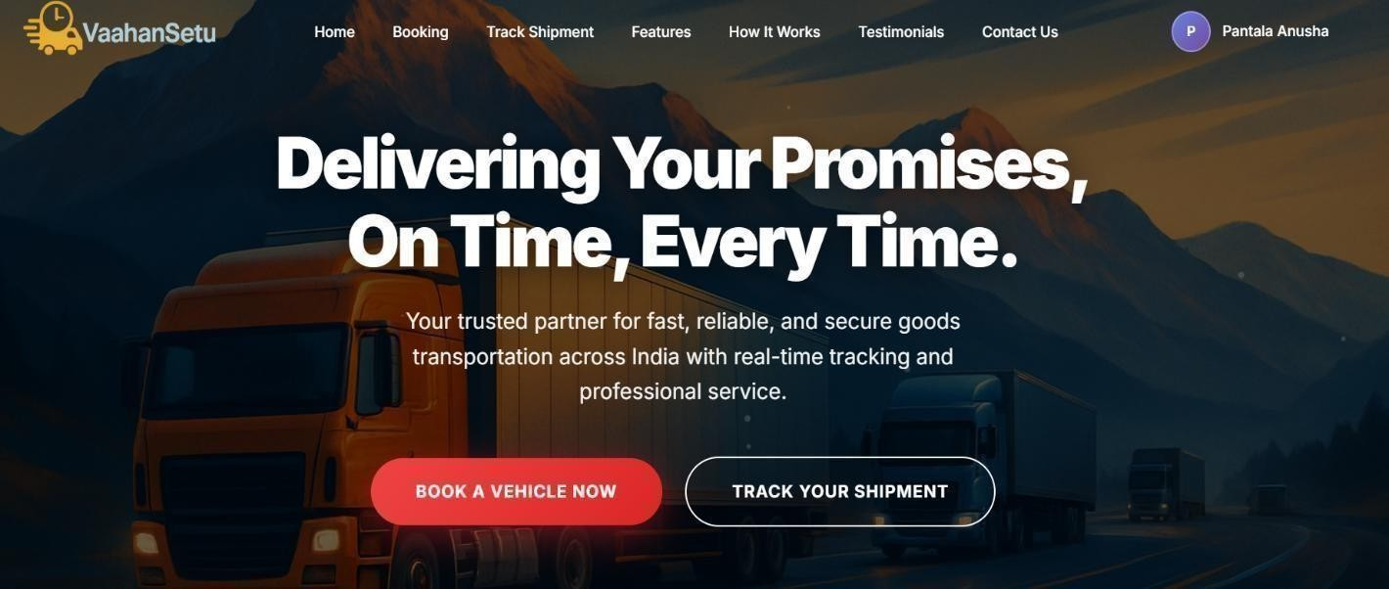
Figure 1. Customer Booking and Tracking Process in VaahanSetu

Driver Partner Registration

The Driver Partner Registration process ensures that drivers are onboarded safely and efficiently on the VaahanSetu platform. Drivers provide their details, submit documents, and get verified before they can start accepting bookings.
      - Sign-Up / Account Creation – The driver registers on the VaahanSetu platform by providing personal details such as name, phone number, and email. They also set a secure password to create their account.
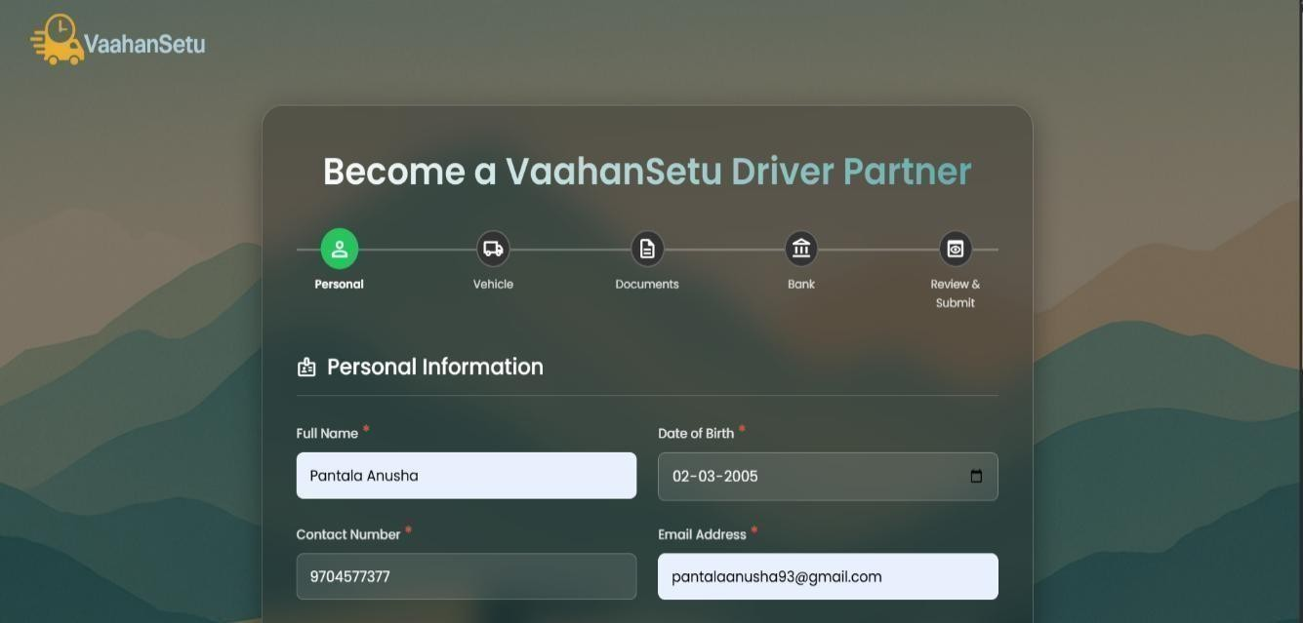
Figure 2. Driver Partner Registration Process in VaahanSetu
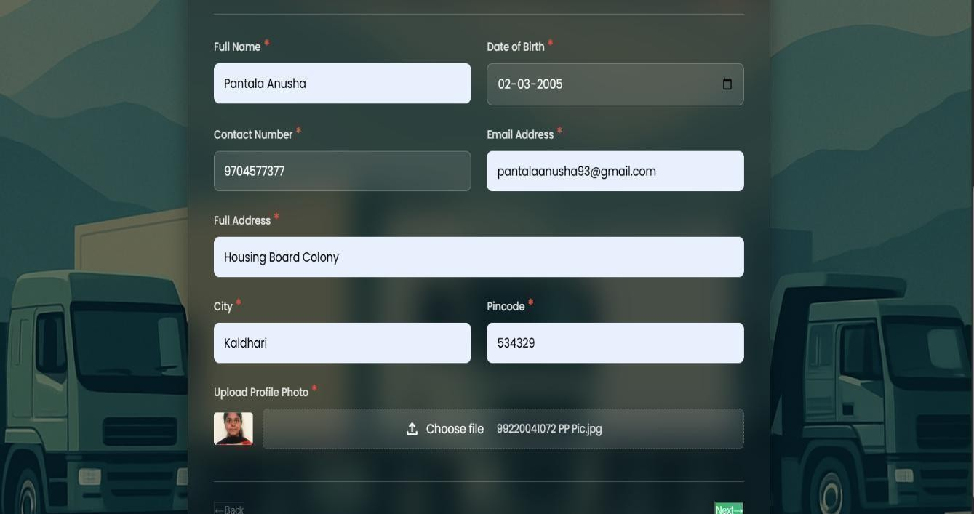
Figure 3. Personal Information

      - Vehicle Details Entry – The driver adds information about their vehicle, including make, model, registration number, and vehicle type, so the platform can assign appropriate bookings.
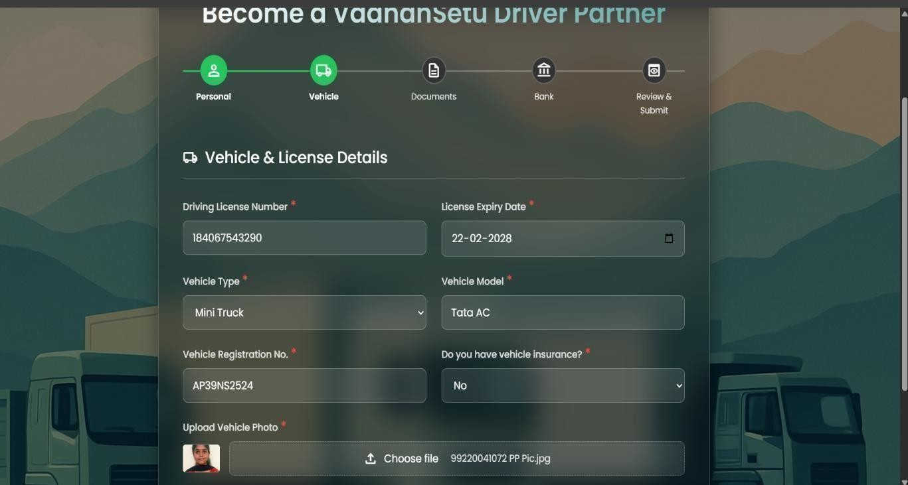
Figure 4. Vehicle Registration Details

      - Document Submission – The driver uploads essential documents like a valid driver’s license, vehicle registration certificate, insurance papers, and government-issued identity proof for verification purposes.
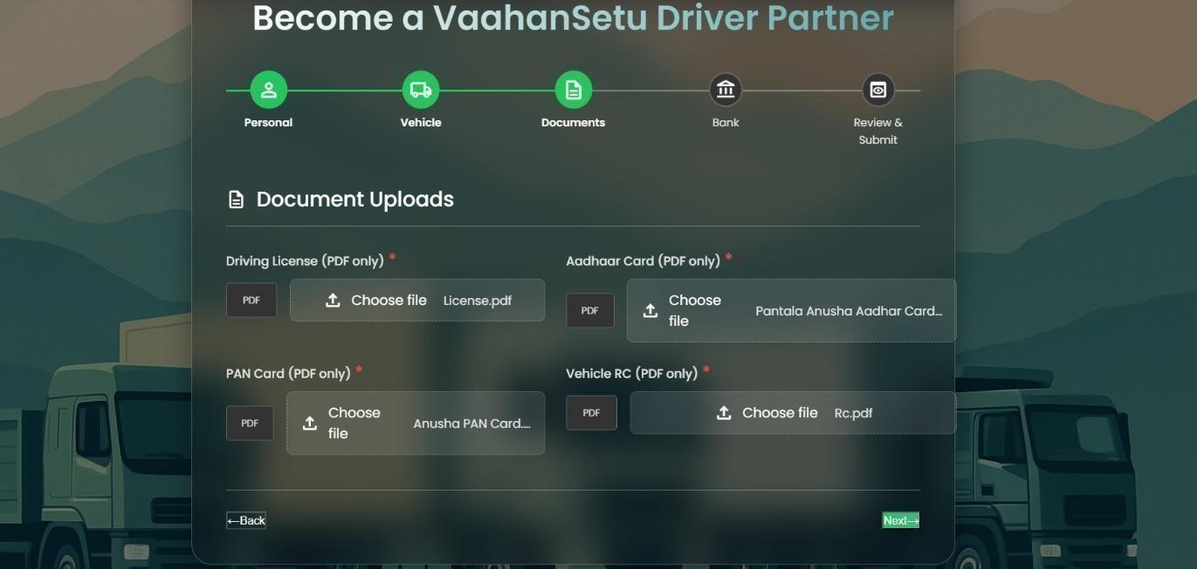
Figure 5. Document Submission Process

      - Background Verification – VaahanSetu performs thorough checks on the driver’s submitted documents, driving record, and credentials to ensure safety and compliance with platform standards.
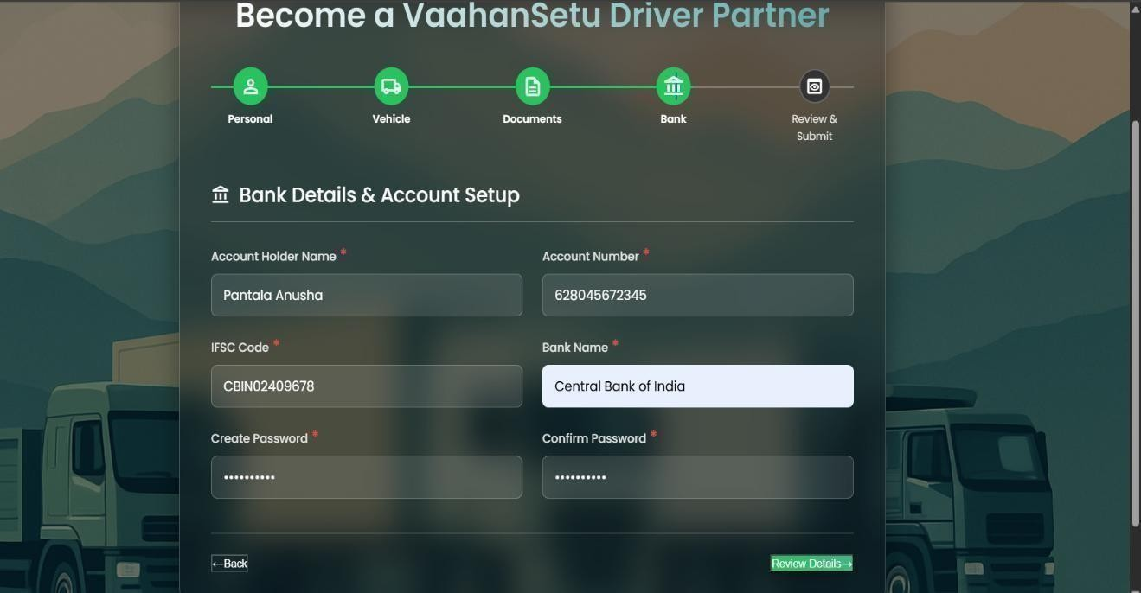
Figure 6. Bank Account Setup

      - Application Submission to Admin – The completed registration is submitted to the admin portal, where the admin reviews and verifies all information before activating the driver account.
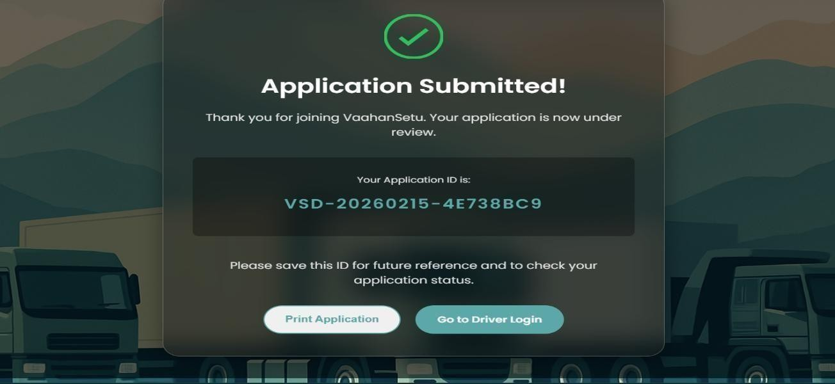
Figure 7. Application Submission

Admin Dashboard
The Admin Dashboard is the central control panel where the admin manages and monitors all driver and customer activities. It allows the admin to review driver applications, verify documents, track bookings, manage payments, and oversee overall platform operations.
Key Features / Steps:

      - Driver Application Review – Admin reviews driver registrations, verifies submitted documents, and approves or rejects applications.
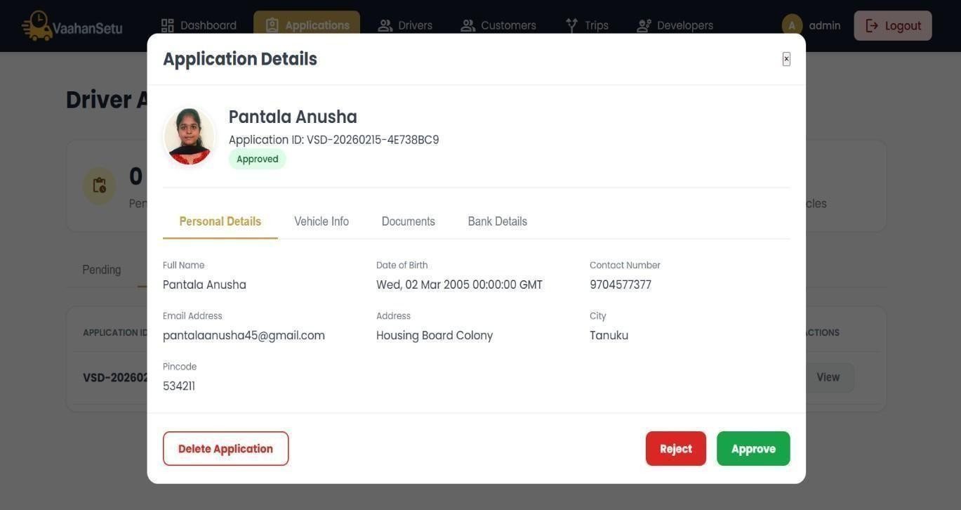
Figure 8. Driver Application Review

      - Booking Management – Admin monitors all customer bookings and tracks their status in real- time.
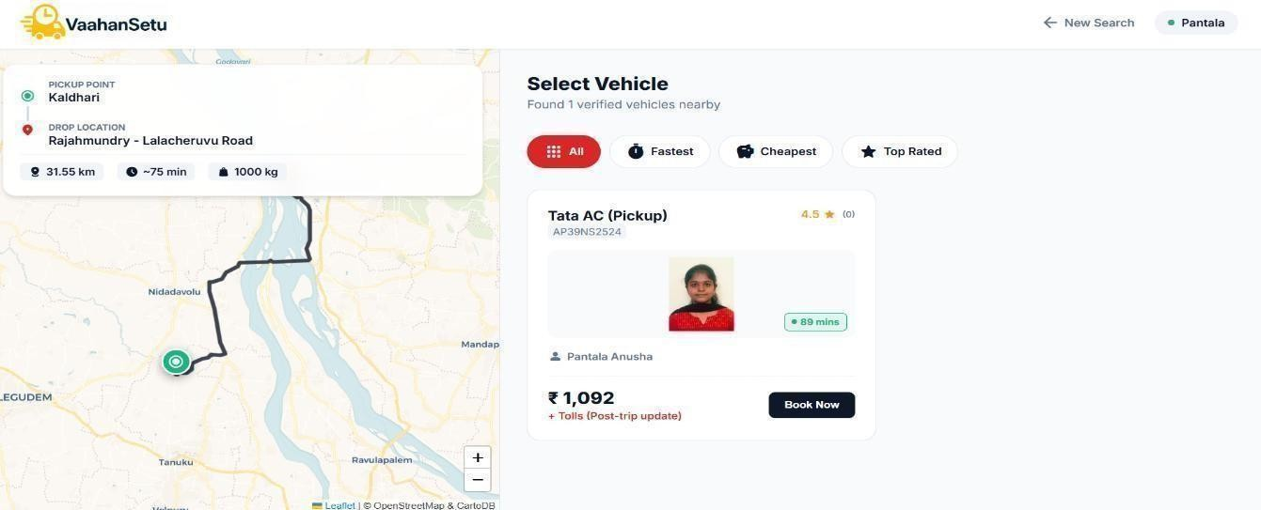
Figure 9. Booking Details

      - Payment Management – Admin manages driver payouts, refunds, and financial records.
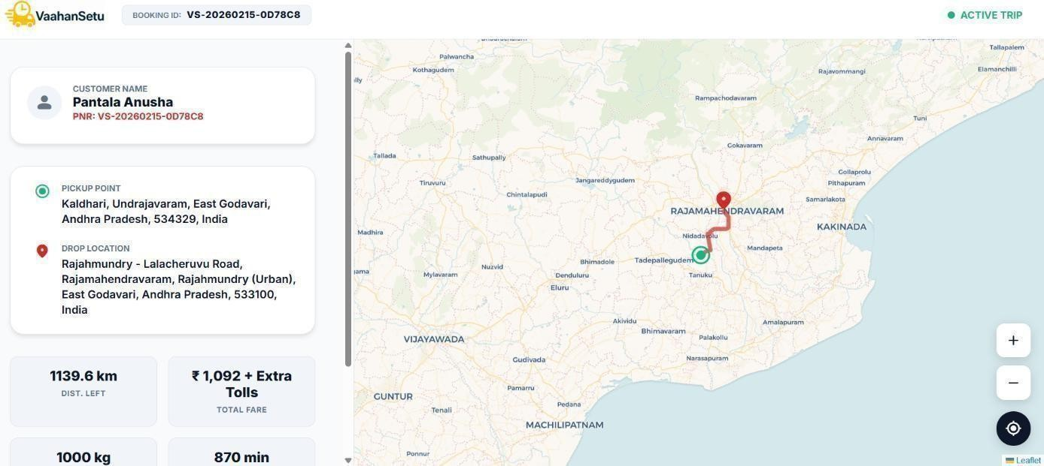

Figure 10. Payment Details

      - Analytics & Reports – Provides data on driver performance, booking trends, and platform usage for operational insights.
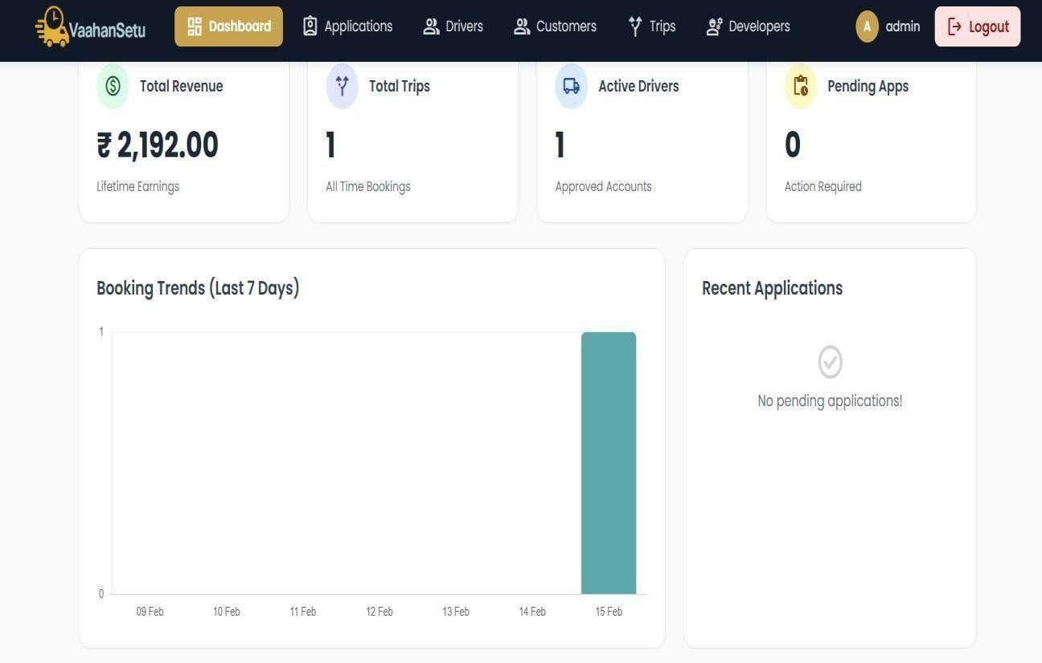
Figure 11. Trends & Analytics of Revenue

Authentication and Authorization
Authentication and Authorization are essential security components of the VaahanSetu system. Authentication ensures that only registered users—such as customers, driver partners, and administrators—can access the platform by verifying their identity using secure login credentials like email/phone number and password.
Authorization, on the other hand, controls what actions each authenticated user is allowed to perform within the system. For example, customers can book and track services, drivers can manage bookings and update availability, and admins can review applications and oversee platform operations.
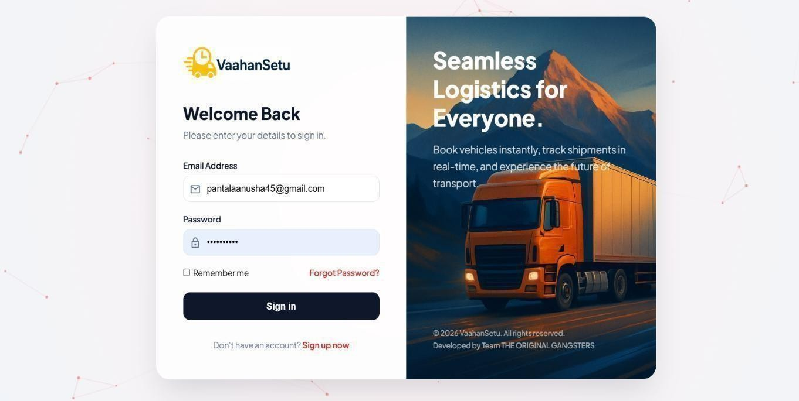
Figure 12. Customer Authentication Page
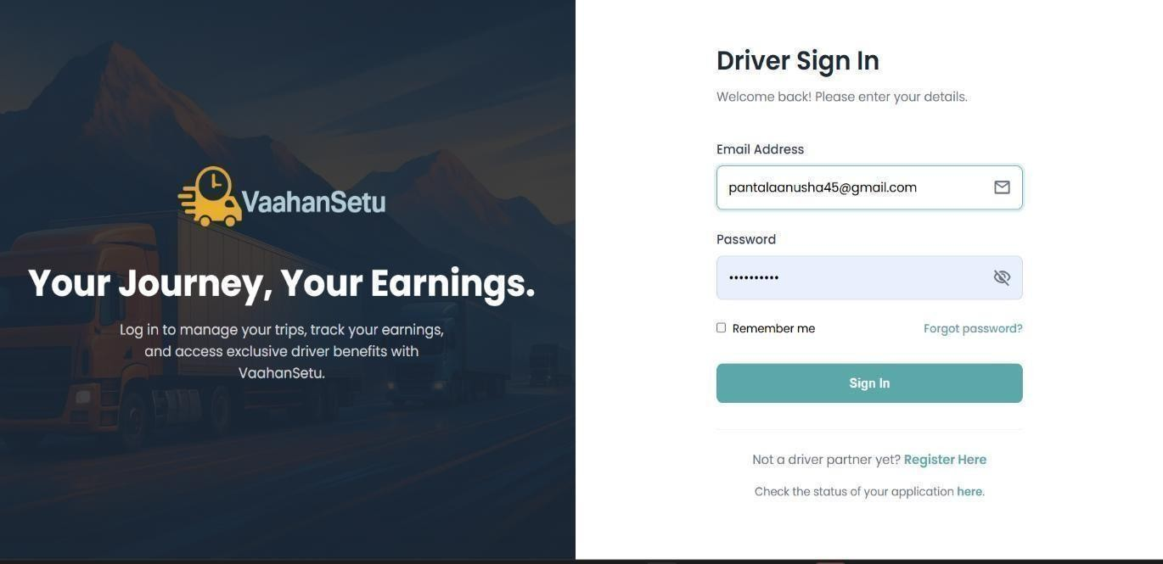
Figure 13. Driver Authentication Page

Notification and Email Verification
The Notification and Email Verification module in VaahanSetu ensures secure communication and real-time updates between the system and its users. Email verification is performed during user registration to confirm the authenticity of the provided email address. A verification link or OTP is sent to the user’s email, and the account is activated only after successful verification.
The notification system keeps customers, drivers, and administrators informed about important activities such as booking confirmations, status updates, payment notifications, driver approvals, and system alerts. Notifications may be delivered through email, SMS, or in-app alerts to ensure timely communication.
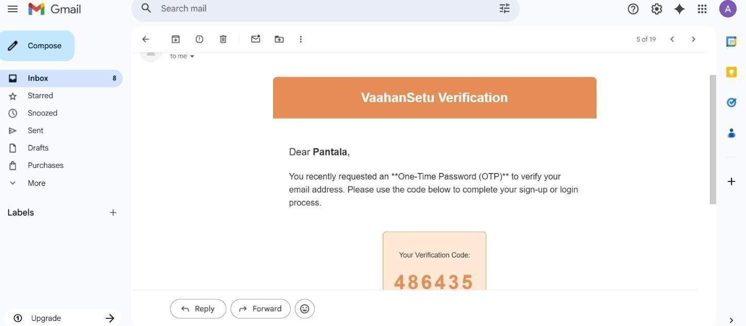
Figure 14. One-Time Password (OTP) Authentication Flow
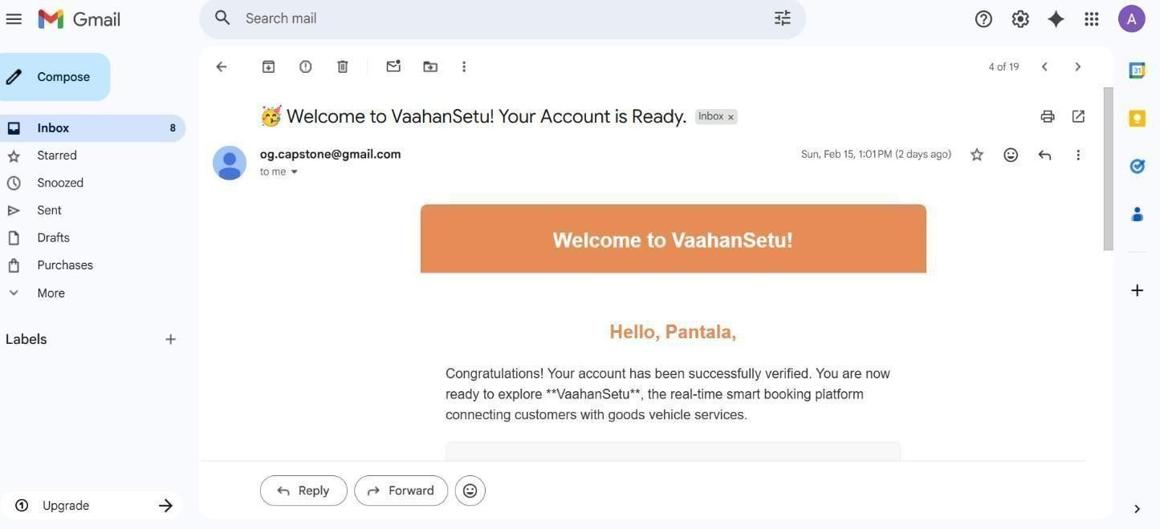
Figure 15. Account Successfully Verified Confirmation Screen

Database Design
    - Conceptual Data Model
The Conceptual Data Model of VaahanSetu represents the high-level structure of the system and illustrates how different entities interact with each other. It defines the primary components of the platform, such as users, bookings, vehicles, and payments, along with their relationships.The system consists of major entities such as Admin, Customer, Driver, Vehicle, Booking, and Payment.
- A Customer can create multiple Bookings, and each booking is assigned to one Driver and one Vehicle.
- The Driver entity maintains personal details, vehicle information, and bank details for payment processing.
- The Admin entity manages driver registrations, verifies applications, and monitors overall platform activities.
- The Booking entity connects Customer, Driver, and Vehicle information, acting as the central operational entity.
- The Payment entity stores transaction details related to completed bookings.
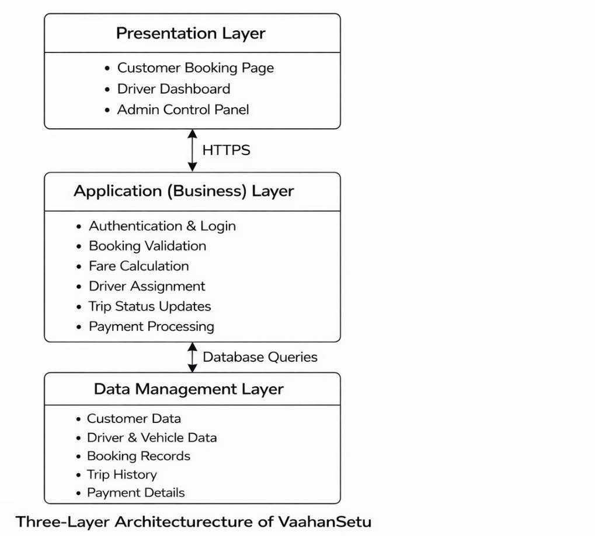
Figure 16. Three-layer Architecture of VaahanSetu

    - Logical Database Structure
The Logical Database Structure of VaahanSetu defines how data is organized into tables, attributes, and relationships within the system. It translates the conceptual data model into structured relational tables with primary keys and foreign keys.

Main Tables and Relationships

      - Customer Table – Stores customer details such as Customer_ID (Primary Key), Name, Email, Phone Number, Address, and Password.
      - Driver Table – Contains Driver_ID (Primary Key), Name, Contact Details, License Number, Vehicle_ID (Foreign Key), Bank Details, and Status.
      - Vehicle Table – Includes Vehicle_ID (Primary Key), Vehicle Type, Registration Number, Capacity, and Driver_ID (Foreign Key).
      - Booking Table – Stores Booking_ID (Primary Key), Customer_ID (Foreign Key), Driver_ID (Foreign Key), Pickup Location, Drop Location, Goods Type, Distance, Fare, and Booking Status.
      - Payment Table – Contains Payment_ID (Primary Key), Booking_ID (Foreign Key), Payment Method, Payment Status, Amount, and Transaction Date.
      - Admin Table – Stores Admin_ID (Primary Key), Username, Password, and Role.
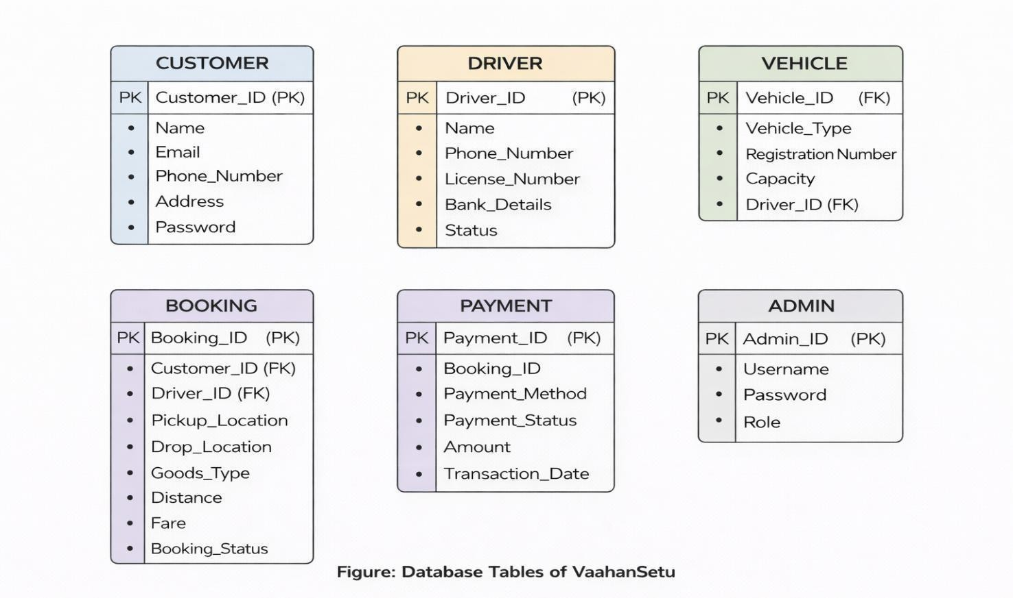
Figure 17. Database Tables of VaahanSetu

User Interface Design
    - User Flow Diagram
The User Flow Diagram of VaahanSetu – Integrated Logistics Management System illustrates how different database tables interact during the execution of a booking process. The system flow begins when a customer registers and creates a booking request. This diagram represents the logical flow of data between tables and shows how primary and foreign keys establish relationships to maintain data integrity and consistency within the system.
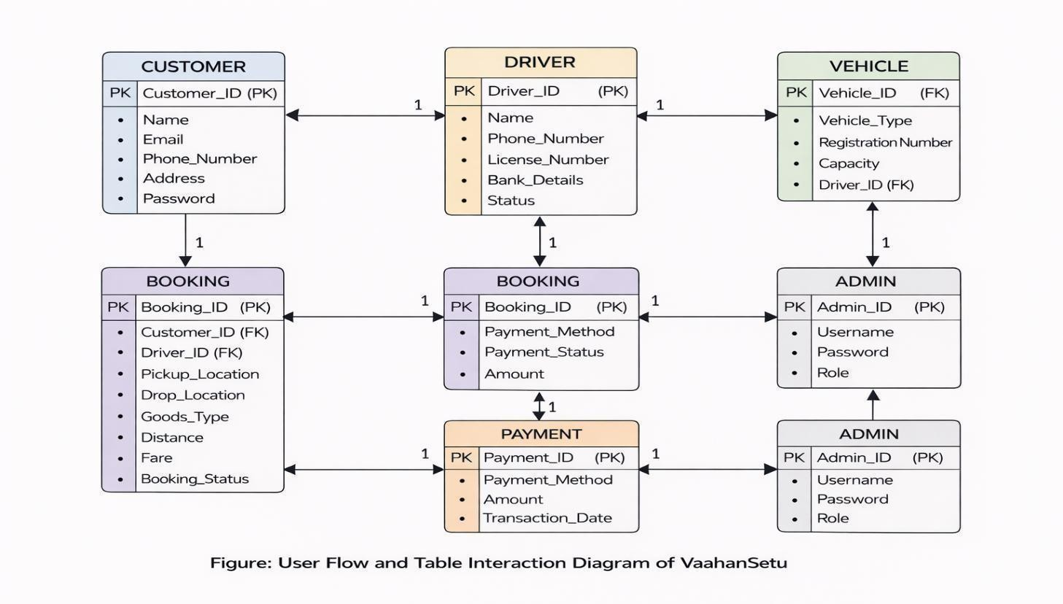
Figure 18. User Flow and Interaction Diagram

Home Page
The Home Page of VaahanSetu – Integrated Logistics Management System acts as the main entry point of the platform. It is designed with a clean and modern layout to clearly present the system’s purpose and services. The page highlights the tagline “Logistics Reimagined. Mobility Simplified.” to reflect the goal of making transportation booking easy and efficient. The homepage provides quick navigation options for Driver, Admin, and Login, allowing different users to access their respective modules.
Key Points:

      - Provides clear navigation for Customer, Driver, and Admin access.

      - Displays system tagline and service description to explain platform objectives.

CONCLUSION & FUTURE SCOPE
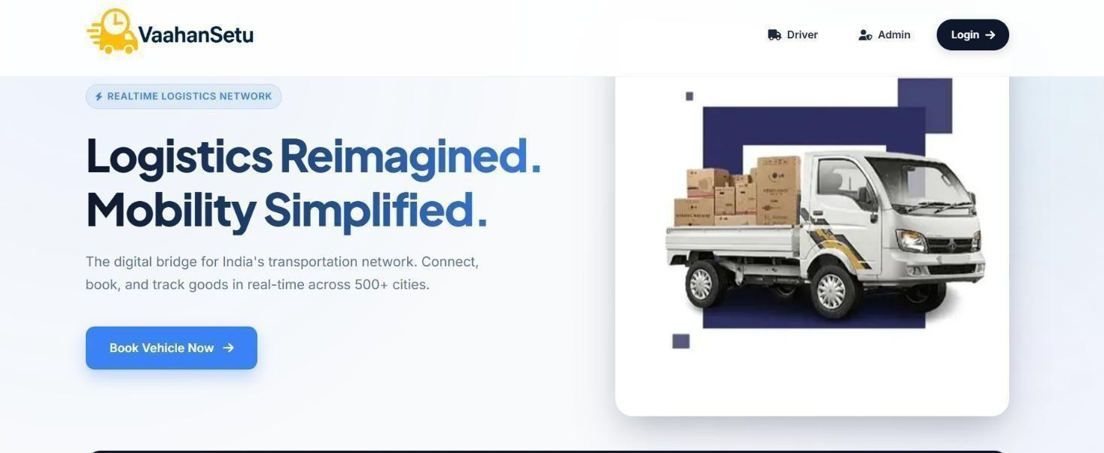
Figure 19. Home Page of Vaahansetu

Booking Page
The Booking Page of VaahanSetu allows customers to enter shipment and personal details to request transportation services. Users provide pickup and drop locations, load weight, and vehicle type to generate a suitable quote.
Key Points:

      - Collects personal, pickup, and delivery details for booking confirmation.

      - Allows vehicle selection based on load weight and transportation requirements.

      - Provides cost-related options such as toll payment preference and vehicle availability search.
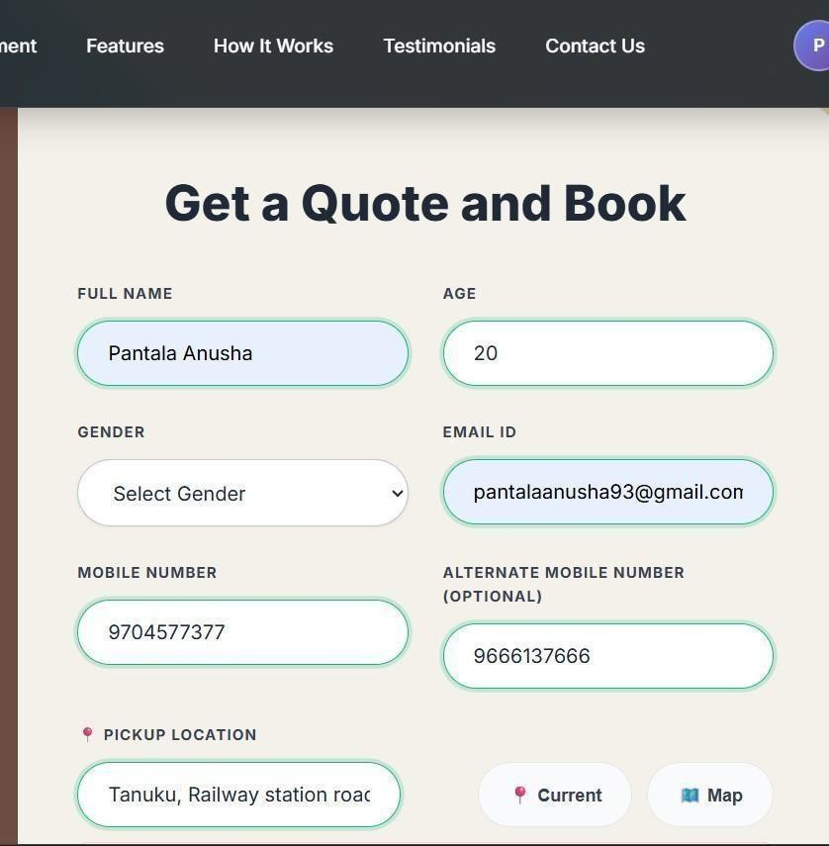
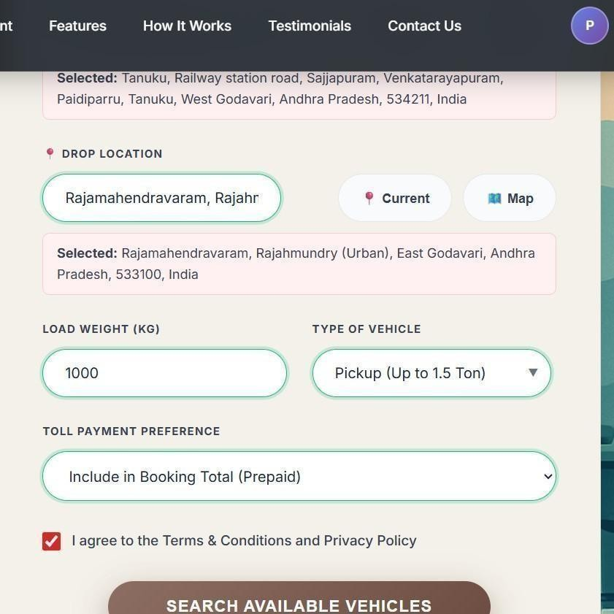
Figure 20. Booking Page Interface of VaahanSetu Figure 21. Goods Load Information Interface

CHAPTER-V IMPLEMENTATION

Technology Stack

The technology stack of VaahanSetu – Integrated Logistics Management System is designed to ensure efficient performance, security, scalability, and maintainability. The system is built using a combination of frontend technologies, backend frameworks, database systems, and external API integrations to support real-time logistics operations.
The major components of the technology stack are as follows:

Front-End Technologies

The front-end layer is responsible for the visual interface and user interaction. It is developed using:
  - HTML5 for structuring web pages and CSS3 for styling and responsive design

  - JavaScript for dynamic behavior and client-side validation

Back-End Technologies

The backend handles business logic, request processing, and system operations. It includes:
  - Server-side programming framework for handling routing and logic

  - Implementation of booking validation and fare calculation algorithms

Database System

A relational database management system (RDBMS) is used for structured data storage. It manages:
  - Customer details

  - Driver profiles and vehicle records

  - Booking transactions and trip history

Comparison of Alternative Technologies

Flask vs Django (Backend Framework)

Feature | Flask | Django
Learning Curve | Easy | Moderate
Flexibility | High  (lightweight, customizable) | Structured but less flexible
Suitable For | Custom, API-focused apps | Large, structured enterprise apps
Table 1. Comparison of Alternative Technologies

Decision: Flask was preferred due to its lightweight structure, easier customization, and suitability for REST API development required for geolocation, and reporting modules.

MySQL vs NoSQL (Database Choice)

Factor | MySQL (Relational) | NoSQL (Document-based)
Data Structure | Highly structured | Flexible schema
Querying | Strong SQL support | Weaker complex querying
Consistency | High | Eventual consistency
Use Case Fit | Suitable for issue management,  user records | Suitable for unstructured or large-scale  data
Table 2. Comparison of MySQL and NoSQL Databases

Decision: MySQL was chosen because booking records, customer accounts, driver details, and trip data require structured storage with strong relational integrity and reliable transactions.

Programming Languages and Tools

The implementation of VaahanSetu was carried out using a structured development environment and reliable programming technologies. The selected tools and languages support efficient coding, smooth backend processing, database connectivity, and real-time booking management.

Programming Languages

        - Python (Flask Framework) – Used for backend development, routing, authentication handling, booking logic, fare computation, and integration of external services.
        - JavaScript – Implemented for dynamic content handling and improving user interaction.

Development Tools

        - Visual Studio Code – Used as the primary development environment for writing, organizing, and debugging source code.
        - MySQL – Used for structured data storage and relational database management.

Frameworks and Libraries

To support efficient development and structured implementation, the VaahanSetu system utilizes selected frameworks and supporting libraries that simplify backend processing, database communication, and dynamic content rendering.

Backend Framework

  - Flask – A lightweight Python web framework used to manage routing, handle HTTP requests, implement business logic, and connect frontend interfaces with the database.

Database Connectivity Libraries

  - MySQL Connector / Flask-MySQL Integration – Enables secure interaction between the Flask application and the MySQL database, supporting query execution and transaction management.

Security and Utility Libraries

  - Flask Session Management Tools – Handle user sessions and access control.
  - Password Hashing Utilities – Ensure secure storage of user credentials through encryption.

Implementation of Modules

    - Customer Booking Implementation

The customer booking functionality of VaahanSetu was implemented to provide a smooth, secure, and structured process for reserving transportation services. The module connects the user interface with backend logic to handle booking requests, fare computation, and database storage efficiently.

- Authenticated users can access the booking form after successful login.
- Customers enter pickup and drop locations along with vehicle type selection.
- The system validates user inputs to prevent incomplete or incorrect data submission.
- Distance-based fare is calculated dynamically using predefined pricing logic.
- Booking details are stored in the database with a unique booking identification number.

Admin Dashboard Implementation

The Admin Dashboard of VaahanSetu was implemented to provide centralized control and monitoring of all system activities. This module enables administrators to supervise bookings, manage users, verify drivers, and analyze platform performance through a secure and structured interface. The dashboard integrates backend logic with database queries to present real -time operational data.

- Secure admin authentication is required to access the dashboard.
- Administrators can view all customer bookings and trip details.
- Driver registration requests can be verified, approved, or rejected.
- The system displays real-time statistics such as bookings, active trips, and completed rides.
- Revenue summaries and booking trends are generated for performance analysis.

Driver Registration and Verification Implementation

The driver registration and verification module in VaahanSetu is implemented to ensure that only authorized and verified drivers are allowed to provide transportation services on the platform. This

module manages driver onboarding through a structured multi-step registration process integrated with backend validation and database storage.

- Drivers are required to submit personal details, vehicle information, and mandatory documents such as Driving License, Aadhaar, PAN, and Vehicle Registration Certificate.

- The admin reviews submitted details and either approves or rejects the registration request based on document authenticity and completeness.

- Only approved drivers gain access to the driver dashboard and are eligible to accept booking requests.

- Status updates regarding approval or rejection are communicated to drivers through the system interface.

Fare Calculation Logic

The fare calculation logic in VaahanSetu is implemented to provide a transparent and consistent pricing mechanism for transportation services. The computation is performed at the backend using Python (Flask), where the system processes user-entered pickup and drop locations to determine the total travel distance. Based on this distance and the selected vehicle category, the system applies predefined pricing rules to calculate the estimated fare.

Tracking and Status Update Logic

The Tracking and Status Update Logic in VaahanSetu is implemented to provide real-time visibility of trip progress for both customers and administrators. This module ensures transparent communication between system components by updating booking stages dynamically based on driver actions and backend processing.

Trip Status Workflow

Each booking progresses through predefined stages such as Booking Confirmed, Driver Assigned, Trip Started, and Trip Completed. These status values are stored in the database and updated .

Real-Time Update Mechanism

When a driver accepts a ride or updates trip progress, the backend processes the request and immediately updates the corresponding booking record. The updated status is then reflected on the customer dashboard, ensuring timely information display.

Database Synchronization

All status changes are recorded in the database to maintain accurate trip history and tracking logs. This ensures data consistency and allows administrators to monitor active and completed trips efficiently.

Integration of Modules

The Integration of Modules in VaahanSetu ensures seamless communication and coordination between different functional components such as Customer Booking, Driver Management, Admin Dashboard, Fare Calculation, and Tracking Logic. The system follows a structured request-response architecture where all modules interact through the backend framework.

The customer booking module is connected to the fare calculation logic to generate accurate pricing before confirmation. Once a booking is created, it is linked to the driver management module to check availability and assign trips. The tracking and status update module continuously synchronizes data between drivers and customers by updating trip progress in real time

Trade-Offs in API Usage
Google Maps API vs OpenStreetMap

Aspect | Google Maps API | OpenStreetMap
Accuracy | Highly accurate, global coverage | Variable accuracy
Features | Reverse geocoding, automatic  suggestions, maps | Basicmaps, limited  geocoding
Cost | Free tier + paid usage | Completely free
Integration Ease | Very high | Moderate
Table 3. Google Maps API vs OpenStreetMap Feature Comparison

System Impact and Benefits

The VaahanSetu – Integrated Logistics Management System creates a significant impact by digitizing transportation booking and management processes that were traditionally handled manually. The platform connects customers, drivers, and administrators on a single system, improving coordination and reducing delays in service delivery. Automated workflows for booking, fare calculation, and driver verification help streamline logistics operations and minimize human errors.

One of the major benefits of the system is improved transparency. Customers can view fare estimates, track trip progress, and access booking history, which increases trust in the service. Drivers benefit from structured trip management and earnings tracking, while administrators gain better control through centralized monitoring and analytics. This integrated approach enhances communication between all stakeholders.

The system also improves operational efficiency by reducing paperwork and manual coordination. Real-time status updates and automated notifications enable faster decision-making and smoother trip execution. Additionally, the modular and scalable architecture allows the platform to support future expansion, making it suitable for deployment across multiple locations.

Overall, VaahanSetu contributes to better resource utilization, improved service reliability, and enhanced user experience. By leveraging modern web technologies and automation, the platform demonstrates practical value in addressing real-world logistics challenges while supporting long- term growth and digital transformation in transportation services.

CHAPTER VI TESTING AND VALIDATION

Testing Methodology

    - Unit Testing

Unit testing focuses on verifying that individual components of the VaahanSetu system work correctly in isolation. Each moduleis tested independently to ensure it produces the expected results.

Scope:

      - Driver Module: Registration, login, and profile updates.

      - Booking Module: Creation, modification, and cancellation of bookings.

      - Admin Module: Driver approvals, vehicle allocation, and report generation.

Methodology:

      - Functions are tested with valid and invalid inputs to ensure correct behavior.

      - Automated tools like JUnit (Java) or PyTest (Python) are used to streamline testing.

Integration Testing

Integration testing ensures that different modules of the VaahanSetu system work together correctly after individual unit testing. It focuses on verifying the interaction and data flow between modules.

Scope:

      - Interaction between Driver and Booking modules.
      - Communication between Booking and Admin modules for approvals and updates.

Methodology:

      - Modules are combined in a step-by-step manner and tested for correct data exchange.

      - Test cases include valid and invalid scenarios to check system behavior under different conditions.
      - Issues found are reported and fixed before moving to system testing.

Benefits:

      - Detects interface and communication issues between modules.
      - Ensures smooth workflow across the system.
      - Confirms that integrated components meet the functional requirements.

System Testing

System testing verifies that the complete VaahanSetu platform functions as intended and meets all specified requirements. It evaluates the system’s behavior in a fully integrated environment, covering both functional and non-functional aspects.

Scope:

      - End-to-end workflows such as booking, driver allocation, and real-time tracking.
      - Notifications, reporting, and user interactions across all modules.
      - System performance under normal and peak load conditions.

Methodology:

      - Execute comprehensive test scenarios covering all functional requirements.
      - Validate both positive (expected use) and negative (error/exception) cases.
      - Monitor system performance, response times, and stability under different conditions.

Benefits:

      - Ensures the system meets functional and operational requirements.
      - Detects issues that may arise only when modules work together.
      - Confirms readiness for deployment and real-world use.

User Acceptance Testing (UAT)

User Acceptance Testing (UAT) verifies that the VaahanSetu system meets the needs and expectations of its end users. It is the final testing phase before deployment, conducted in a real-world or simulated environment.

Scope:

      - Drivers testing booking, navigation, and profile management.
      - Admins validating approvals, reporting, and vehicle allocation workflows.
      - Overall user experience, ease of use, and system responsiveness.

Methodology:

      - End users perform typical tasks using the system and provide feedback.
      - Test scenarios cover both standard operations and edge cases.

Benefits:

      - Confirms the system meets practical operational requirements.
      - Ensures user satisfaction and usability.
      - Reduces risk of deployment issues by addressing real-world concerns.

6.1 Performance Validation

Performance validation is a critical phase of the testing methodology for the VaahanSetu system. It ensures that the platform operates efficiently under different levels of user activity and meets the required standards for speed, scalability, and reliability. The goal of performance validation is not only to identify potential bottlenecks in the system but also to ensure that users experience a smooth, responsive interface during normal operations as well as peak usage periods.

The scope of performance validation covers several key areas. The system’s response time is tested for critical operations such as booking creation, modification, cancellation, and driver assignment. Real-time vehicle tracking and notification updates are tested under simulated high user loads to ensure that the system can handle multiple concurrent requests without delays or data inconsistencies. Database performance is also evaluated by monitoring query execution times and the efficiency of

report generation, ensuring that even large volumes of data do not negatively impact system responsiveness.

The methodology for performance validation involves simulating both normal and peak user loads and monitoring system behavior under these conditions. Metrics such as response time, throughput, CPU usage, memory utilization, and network bandwidth are carefully tracked to identify performance bottlenecks. Stress testing is conducted to evaluate the system’s ability to maintain stability when subjected to unusually high traffic or large data volumes. Load testing helps in determining the scalability of the system and ensures that it can accommodate future growth without compromising performance.

The benefits of thorough performance validation are significant. It guarantees that the system remains stable, responsive, and reliable under varying workloads, enhancing the overall user experience. Potential issues such as slow response times, delayed updates, or system crashes can be identified and resolved before deployment, minimizing the risk of operational disruptions. Performance validation also provides insights for future optimization, enabling the development team to fine-tune the system architecture, database queries, and network usage for maximum efficiency.

In summary, performance validation ensures that the VaahanSetu platform delivers a high - performing, reliable, and scalable solution. By rigorously testing the system under realistic and extreme conditions, it confirms that the platform can meet user expectations and operational demands effectively, providing a seamless experience for drivers, administrators, and customers alike.

6.3 Security Testing Results
Security testing was conducted on the VaahanSetu – Integrated Logistics Management System to evaluate the platform’s ability to protect user data, prevent unauthorized access, and maintain system integrity. The testing process focused on authentication mechanisms, data handling, session management, and protection against common web vulnerabilities. The results indicate that the system implements essential security controls required for a real-world logistics platform.

Authentication Security
The authentication mechanism was tested to ensure only valid users can access system features. Login validation, password encryption, and role-based access control were verified.
  - Passwords are stored using secure hashing techniques to prevent plain-text exposure.

  - Role-based authentication restricts access to customer, driver, and admin functionalities.
  - Invalid login attempts are handled with proper error messages without exposing sensitive information.
  - Session validation prevents unauthorized access to protected pages.

Data Protection and Storage
Database security testing focused on how user, booking, and driver data are stored and retrieved.
  - Sensitive user information is stored in structured tables with controlled access.
  - Database queries use validation to reduce the risk of SQL injection attacks.
  - Document uploads are linked securely to driver profiles.
  - Data consistency checks ensure accurate storage of booking and trip records.

Session and Access Control
Session management was evaluated to verify secure navigation across system modules.
  - Sessions are generated after successful login and cleared on logout.
  - Direct URL access to restricted pages is blocked without authentication.
  - Role-based session checks prevent privilege escalation.
  - Timeout mechanisms help reduce risks from inactive sessions.

API and Integration Security
External integrations such as mapping services were tested to ensure safe communication.
  - API requests are handled through controlled backend routes.
  - Input validation prevents malformed requests from affecting system operations.
  - Error handling avoids exposure of internal system details.
  - Secure communication ensures reliable data exchange between modules.

Security Testing Outcome
The security testing results show that VaahanSetu provides a stable level of protection for authentication, data storage, and module access. While the system meets essential security requirements, additional improvements such as advanced encryption, two-factor authentication, and automated security monitoring can further enhance protection. Overall, the implemented security measures ensure safe and reliable operation of the platform.

CHAPTER VII RESULTS AND DISCUSSION

System Output Screenshots

The outputs of VaahanSetu were validated through UI screenshots for both driver and customer portals. The driver portal shows registration, login, dashboard navigation, booking management, real- time tracking, and feedback submission. The customer portal displays registration, booking creation, status tracking, notifications, and feedback.
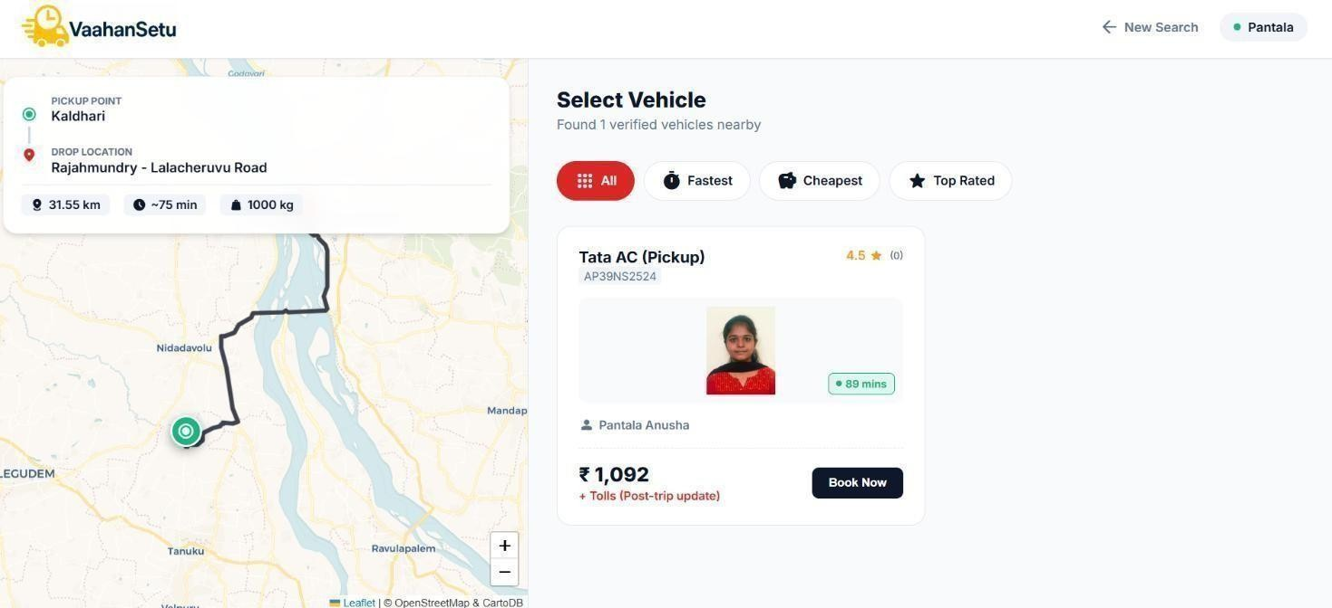
Figure 22. Customer Booking Screenshot(Results Section)
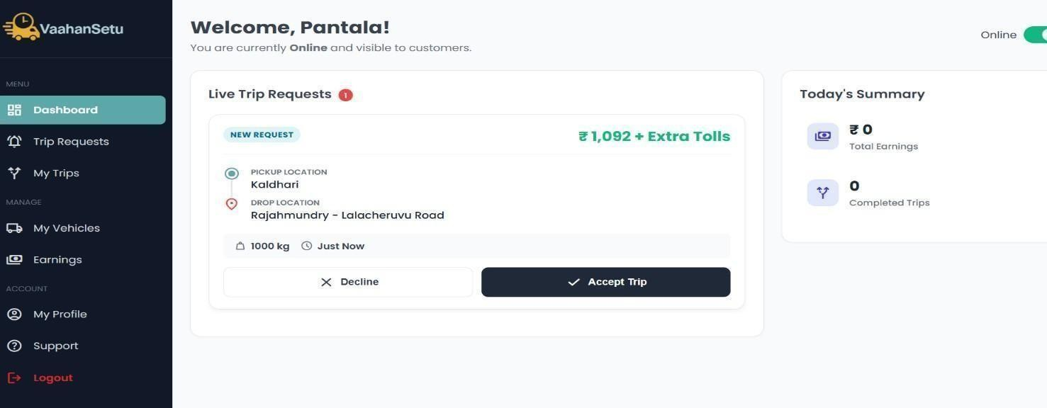

Figure 23. Driver Dashboard Screenshot(Results Section)

Evaluation Metrics

Evaluation metrics are used to measure the effectiveness, efficiency, and reliability of the VaahanSetu system. These metrics help ensure that the system meets both functional and non -functional requirements and provides a high-quality user experience.

Key Metrics:

    - Booking Completion Rate:
Measures the percentage of bookings successfully completed by drivers out of the total bookings made by customers. A higher rate indicates smooth operational efficiency.

Average Response Time:
Tracks the time taken for system responses, such as booking confirmations, route updates, and notifications. Low response times indicate a responsive and efficient system.

Driver Acceptance Rate:
Monitors how many assigned trips are accepted by drivers. A high acceptance rate reflects driver engagement and system reliability.

User Satisfaction:
Collected via feedback and ratings from both customers and drivers. It assesses usability, convenience, and overall satisfaction with the system.

Comparison with Existing Systems

Feature | Traditional/Manual Approach | VaahanSetu
Booking Process | Phone calls or paper-based requests | Guided online booking with  dashboard and notifications
Driver Assignment | Manual allocation by admin | Automated driver assignment  with real-time availability
Location Accuracy | Customer-entered addresses | Google Maps integration with  geolocation tracking
Real-time Tracking | Limited or absent | Live vehicle tracking with route  updates
Notifications & Alerts | Phone or SMS only | In-app notifications for  customers and drivers
Table 4. Comparison of VaahanSetu with Existing System

Challenges Faced During Implementation

During the development and deployment of VaahanSetu, several challenges were encountered and addressed to ensure a robust and efficient logistics management system

Real-Time Vehicle Tracking

  - Integrating accurate GPS-based tracking for multiple vehicles simultaneously.

  - Challenges with data synchronization, latency, and real-time updates on dashboards.

Driver and Booking Management

  - Designing automated driver allocation for overlapping schedules, cancellations, and route optimization.
  - Handling last-minute booking changes efficiently.

Geolocation Accuracy

  - Ensuring precise pickup and drop locations by integrating Google Maps and India Post API.

  - Handling inconsistencies in user-entered addresses.

Scalability and Performance

  - Managing high volumes of concurrent bookings and real-time updates without degrading system performance.
  - Optimizing database queries, server load balancing, and front-end rendering.

User Experience and Usability

  - Creating a modern, intuitive interface for both drivers and customers.

  - Supporting all features for users with varying technical proficiency.

Notification and Alert System

  - Implementing reliable booking confirmations, driver actions, and real-time updates.

  - Ensuring consistency in message delivery across devices.

Discussion of Strengths and Limitations

VaahanSetu demonstrates several strengths as an integrated logistics management platform. One of its major advantages is the centralized connection between customers, drivers, and administrators, which simplifies transportation booking and monitoring. The system provides real-time tracking, automated fare calculation, and structured driver verification, improving transparency and reducing manual coordination. The modular architecture also allows the platform to be extended with additional features without significant redesign.
Another strength of the system lies in its use of modern web technologies and scalable backend design. Secure authentication, database normalization, and role-based access control enhance data protection and system reliability. The admin dashboard provides operational insights such as booking statistics and revenue trends, enabling better decision-making. These features collectively improve efficiency and user experience across the platform.

Despite these strengths, the system has certain limitations primarily related to dependency on external services. Real-time tracking and distance calculation rely on mapping APIs and stable internet connectivity, which may affect performance in low-network areas. Additionally, manual driver document verification can increase processing time, especially when the number of applications grows.
There are also scalability and feature-related limitations in the current implementation. Advanced capabilities such as automated dispatch optimization, integrated digital payments, and mobile applications are planned but not fully implemented. Addressing these limitations through enhanced automation, cloud deployment, and AI-based analytics can further strengthen the system and improve long-term performance.

Analytics and Observations

The analytics and observations stage focuses on examining system performance, user interaction patterns, and operational efficiency within the VaahanSetu – Integrated Logistics Management System. By analyzing booking data, driver activities, trip progress, and administrative reports, valuable insights were obtained regarding how effectively the platform supports logistics operations. The admin dashboard serves as the central interface for viewing these analytics, presenting summarized metrics and activity trends in a structured manner.

The analysis of booking patterns revealed variations in service demand across different time periods. Peak booking intervals indicate higher platform usage and help identify when additional driver availability may be required. Tracking these patterns allows administrators to better plan resource allocation and improve service responsiveness. Similarly, trip completion statistics provide insight into system reliability and overall service success rates.

Driver-related analytics play an important role in evaluating operational productivity. Metrics such as the number of trips accepted, completed rides, and earnings distribution help measure driver engagement and performance. These observations support fair workload distribution and enable administrators to identify highly active drivers or areas where driver availability needs improvement. Monitoring driver behavior also contributes to maintaining service quality.

Revenue analytics generated through booking data offer an overview of platform growth and financial performance. By examining fare trends, booking frequency, and service usage, administrators can assess the economic viability of the system. This information helps in making decisions related to pricing strategies, promotional activities, and future feature investments.

User interaction observations indicate that automated booking, fare calculation, and real -time tracking significantly reduce manual coordination and improve user experience. The structured workflow minimizes errors and enhances transparency between customers and drivers. Additionally, analytics highlight system strengths such as quick booking confirmation and efficient trip status updates while also revealing areas that may benefit from further optimization.
Overall, the analytics and observations demonstrate that VaahanSetu provides effective operational monitoring, improved decision-making capabilities, and enhanced service transparency. The insights obtained from system data create opportunities for future enhancements such as predictive demand analysis, automated driver allocation, and advanced performance dashboards, further strengthening the platform’s scalability and efficiency.

CHAPTER VIII CONCLUSION & FUTURE SCOPE

Conclusion

The VaahanSetu – Integrated Logistics Management System was developed to modernize and simplify transportation and logistics operations. By providing a unified platform for customers, drivers, and administrators, the system streamlines booking, driver assignment, and trip management while reducing reliance on manual processes.
The platform incorporates key features such as guided booking, real-time vehicle tracking, automated notifications, and a comprehensive admin dashboard. These functionalities improve coordination between users, enhance transparency, and ensure that bookings are handled efficiently from creation to completion.
Throughout the development process, various testing methodologies including unit, integration, system, and user acceptance testing were conducted to validate system performance and reliability. The results demonstrate that VaahanSetu is scalable, stable, and capable of handling real-world logistics requirements effectively.
VaahanSetu serves as a robust and user-friendly logistics management solution that enhances service quality and operational efficiency. The system also provides a strong foundation for future enhancements such as mobile application support, advanced analytics, and intelligent route optimization, ensuring continued growth and adaptability.
In summary, VaahanSetu is a robust and user-friendly solution that streamlines transportation workflows, reduces operational delays, and lays the groundwork for future improvements like predictive analytics, advanced reporting, and expanded service features.

Future Enhancements

As VaahanSetu continues to evolve, there are several opportunities to further improve its functionality, efficiency, and user experience. Future enhancements aim to incorporate advanced technologies, expand service capabilities, and provide more intelligent, seamless, and sustainable logistics solutions. These improvements will ensure that the system remains adaptable to changing user needs and industry trends while enhancing operational efficiency and customer satisfaction. Integration of predictive route optimization to suggest the fastest and most efficient routes for drivers.

    - Incorporation of multi-modal transport options, including cargo, bikes, and shared vehicles.

    - Advanced analytics and reporting tools for administrators to gain deeper insights into booking patterns and operational efficiency.
    - Implementation of AI-powered chatbots and virtual assistants for enhanced customer support and query resolution.
    - Development of a mobile app with offline support for drivers to manage bookings in areas with limited connectivity.
    - Integration of digital payment gateways and automated invoicing for seamless transactions.
    - Enhanced security features, including multi-factor authentication and real-time fraud detection.
    - Real-timefeedback and rating system for continuous improvement of driver performance and customer satisfaction.
    - Expansion of geolocation services to include traffic-aware routing and predictive arrival times.
    - Incorporation of sustainability features, such as eco-friendly route suggestions and vehicle emissions tracking.

REFERENCES

- Dintén, R., García, S., & Zorrilla, M. (2023). Fleet management systems in Logistics 4.0 era: a real time distributed and scalable architectural proposal. Procedia Computer Science, 217, 806-815.
- Kotsialos, A., & Vassilakopoulou, P. (2023). Fleet management enterprise systems and traffic control synergies: a literature review and research agenda. Procedia Computer Science, 219, 529-536.
- Dui, H., Zhang, S., Liu, M., Dong, X., & Bai, G. (2024). IoT-enabled real-time traffic monitoring and control management for intelligent transportation systems. IEEE internet of things journal, 11(9), 15842 15854.
- Yin, Y., Wang, H., & Deng, X. (2024). Real-time logistics transport emission monitoring-integrating artificial intelligence and internet of things. Transportation Research Part D: Transport and Environment, 136, 104426.
- Elassy, M., Al-Hattab, M., Takruri, M., & Badawi, S. (2024). Intelligent transportation systems for sustainable smart cities. Transportation Engineering, 16, 100252.
- Hazarika, A., Choudhury, N., Nasralla, M. M., Khattak, S. B. A., & Rehman, I. U. (2024). Edge ML technique for smart traffic management in intelligent transportation systems. IEEE Access, 12, 25443 - 25458.
- Zhang, R., Mao, J., Wang, H., Li, B., Cheng, X., & Yang, L. (2024). A survey on federated learning in intelligent transportation systems. IEEE Transactions on Intelligent Vehicles.
- Zhou, X., Liang, W., Kawai, A., Fueda, K., She, J., & Wang, K. I. K. (2024). Adaptive segmentation enhanced asynchronous federated learning for sustainable intelligent transportation systems. IEEE Transactions on Intelligent Transportation Systems, 25(7), 6658-6666.
- Belkacem, K. (2024). Integrating Edge and Cloud Computing for Efficient Big Data Processing in IoT Environments: Enhancing Smart City Applications with Fog Computing. Studies in Knowledge Discovery, Intelligent Systems, and Distributed Analytics, 14(9), 1-14.
- Afzal, I., Ahmad, Z., & Algarni, A. (2025). A Latency-Aware and Fault-Tolerant Framework for Resource Scheduling and Data Management in Fog-Enabled Smart City Transportation Systems. Computers, Materials & Continua, 82(1).
- Behura, A., Kumar, A., & Jain, P. K. (2025). A comparative performance analysis of vehicular routing protocols in intelligent transportation systems. Telecommunication Systems, 88(1), 26

- Singh, H. (2025). The impact of advancements in artificial intelligence on autonomous vehicles and modern transportation systems. Available at SSRN 5267884.
- Liu, R., & Shin, S. Y. (2025). A review of traffic flow prediction methods in intelligent transportation system construction. Applied Sciences, 15(7), 3866.
- Wazid, M., Singh, J., Pandey, C., Sherratt, R. S., Das, A. K., Giri, D., & Park, Y. (2025). Explainable deep Learning-Enabled malware attack detection for IoT-Enabled intelligent transportation systems. IEEE Transactions on Intelligent Transportation Systems, 26(5), 7231-7244.

- Deng, W., Shang, S., Zhang, L., Lin, Y., Huang, C., Zhao, H., ... & Chen, H. (2025). Multi- strategy quantum differential evolution algorithm with cooperative co-evolution and hybrid search for capacitated vehicle routing. IEEE Transactions on Intelligent Transportation Systems.

- Poornima, E., Muthu, B., Agrawal, R., Kumar, S. P., Dhingra, M., Asaad, R. R., & Jumani, A. K. (2025). Fog robotics-based intelligence transportation system using line-of-sight intelligent transportation. Multimedia Tools and Applications, 84(29), 35333-35361.

- Sogbe, E., Susilawati, S., & Pin, T. C. (2025). Scaling up public transport usage: a systematic literature review of service quality, satisfaction and attitude towards bus transport systems in developing countries. Public Transport, 17(1), 1-44.

- Ahmad Jan, M., Adil, M., Brik, B., Harous, S., & Abbas, S. (2025). Making sense of big data in intelligent transportation systems: Current trends, challenges and future directions. ACM Computing Surveys, 57(8), 1-43.

- Telikani, A., Sarkar, A., Du, B., Santoso, F., Shen, J., Yan, J., ... & Yap, E. W. (2025). Autonomous Aerial Vehicles-Aided Intelligent Transportation Systems: Vision, Challenges, and Opportunities. IEEE communications surveys & tutorials, 27(6), 3772-3819.

- Lu, Y., Chen, S., Zhang, X., Pan, X., Gang, Y., & Wang, C. (2025). A quantum-enhanced heuristic algorithm for optimizing aircraft landing problems in low-altitude intelligent transportation systems. Scientific Reports, 15(1), 21606.

2025 IEEE 1st International Conference on Recent Trends in Computing and Smart Mobility (RCSM 2025)

Quantum-Edge AI Framework for Real-Time Vehicle-Cargo Matching in Intelligent Transportation Systems
P. Velmurugadass P. Anusha T. Navya Sri

Department of Computer Scienceand Engineering
Kalasalingam Academy of Research and Education
Department of Computer Science and Engineering
Kalasalingam Academy of Research and Education
Department of Computer Science and Engineering
Kalasalingam Academy of Research and Education

Krishnankoil, India Krishnankoil, India Krishnankoil, India dass.spv@gmail.com pantalaanusha93@gmail.com navyasritera95@gmail.com

K. Chaitanya Lakshmi Y. Charvitha

Department of Computer Scienceand Engineering
Kalasalingam Academy of Research and Education
Department of Computer Science and Engineering
Kalasalingam Academy of Research and Education

Krishnankoil, India Krishnankoil, India chaitanyakotaru016@gmail.com yangareddycharvitha@gmail.com

Abstract—Efficient and privacy-preserving vehicle–cargo matching remains a significant challenge in intelligent transportation systems (ITS) due to dynamic network conditions, decentralized data sources, and limited computationalresources at the edge. This paper proposes a Quantum-Edge AI Framework that integrates quantum optimization, edge artificial intelligence (AI), and federated learning to achieve secure, low-latency, and scalable decision-making for real-time logistics. The framework employs a Quantum Approximate Optimization Algorithm (QAOA) to solve a multi-objective cost function encompassing distance, time, and environmental impact, while Neural Architecture Search (NAS)-optimized edge models enable rapid inference under resource constraints. Privacy and trust are preserved through a hierarchical federated learning scheme supported by secure aggregation and anomaly detection mechanisms. A digital twin environment is developed to validate the proposed architecture under realistic transportation conditions, demonstrating enhanced adaptability and resilience to network fluctuations. The framework represents a unified approach toward sustainable, intelligent, and privacy-aware transportation, paving the way for next-generation urban mobility solutions aligned with global sustainability goals.
Keywords— quantum optimization, edge artificial intelligence (AI), federated learning, intelligent transportation systems (ITS), vehicle–cargo matching, digital twin, sustainable mobility, smart logistics, Sustainable Development Goal (SDG) 9: Industry, Innovation, and Infrastructure, SDG 11: Sustainable Cities and Communities.
I. Introduction
One of the most important elements of contemporary Intelligent Transportation Systems (ITS) is effective and secure real-time vehicle–cargo matching, which forms the foundation for attaining urban mobility efficiency, sustainability, and safety [1]. Low-latency operations, lower fuel usage, and environmentally friendly routing are becoming more and more important to transportation networks as e- commerce, ride-sharing, and on-demand logistics grow in popularity. A paradigm transition from
conventional centralized cloud architectures to decentralized, intelligent frameworks that can instantly adjust to dynamic and unexpected traffic scenarios is required due to the exponential expansion of connected vehicles and logistics platforms.
For processing, communication, and coordination, traditional cloud-based ITS architectures mostly rely on centralized data centers. Even though cloud infrastructures offer a lot of processing power, scalability in real-world deployments is greatly impacted by the latency bottlenecks, bandwidth restrictions, and single points of failure they bring [2]. Concerns over user trust and regulatory compliance are further raised by the ongoing transmission of private user, geolocation, and vehicle data to distant cloud servers, which makes them more susceptible to cyberattacks and data breaches. As a result, new transportation systems that aim for both resilience andregulatoryalignment must enable privacy- preserving intelligence closer to the data source.
Large-scale combinatorial optimization problems that are still computationally unsolvable using traditional techniques can nowbe solved withquantumcomputing, a game-changing technology [3]. Unlike heuristic or metaheuristic algorithms, methods like the Quantum Approximate Optimization Algorithm (QAOA) use quantum superposition and entanglement to search large solution spaces in parallel and arrive at near-optimal solutions in fewer iterations. Apossible method for real-time vehicle–cargo assignment is provided by QAOA's ability to maximize multi-objective functions in the context of ITS, including travel distance, matching time, and energy usage. Current quantum techniques, however, usually rely on distant quantum cloud computers, which add latency and communication overheads, diminishing their benefits in latency-sensitive applications like autonomous coordination and smart logistics.
Simultaneously, Edge ArtificialIntelligence(Edge AI) has transformed the computational environment by making on- device processing possible right at the edge of the network. Vehicles and roadside devices can process real-time data

12/5/25, 8:01 PM Gmail - RCSM 2025: Acceptance of Paper ID 1198

PANTALA ANUSHA <pantalaanusha93@gmail.com>

RCSM 2025: Acceptance of Paper ID 1198
1 message

Microsoft CMT <noreply@msr-cmt.org> 11 November 2025 at 23:57 To: Pantala Anusha <pantalaanusha93@gmail.com>

Dear Pantala Anusha, Greetings!
Thank you for submitting your research article to the 1st IEEE International conference on Recent Trends in Computing and Smart Mobility Conference (RCSM 2025), which will be held in hybrid mode on Dec 5-6, 2025, at MANIT Bhopal, India.

We are pleased to inform you that based on reviewers’ comments, your paper titled "Quantum-Edge AI Framework for Real-Time Vehicle-Cargo Matching in Intelligent Transportation Systems" has been accepted for presentation during RCSM 2025, and publication in the proceedings to be published in IEEE Xplore, subject to the condition that you submit a revised version as per the comments, shared with the corresponding author. It is also required that you prepare a response to each comment from the reviewer and upload it as a separate file along with the revised paper. IEEE XPLORE is indexed with the world’s leading Abstracting & Indexing (A&I) databases, including ISI / SCOPUS/ DBLP/ EI-Compendex
/ Google Scholar.
The similarity index in the final paper must be less than 20%. Please note that high plagiarism, AI- generated text, and any kind of multiple submissions of this paper to other conferences or journals will lead to rejection at any stage.
Please Note that Conference proceedings that meet IEEE quality review standards will be eligible for inclusion in the IEEE Xplore Digital Library. IEEE reserves the right not to publish any proceedings that do not meet these standards.
Registration Steps for RCSM 2025
Step 1: Explore the Registration Link https://www.rcsm2025.com/registration/index.html
Step 2: Make the payment, keep the proof of the payment (transaction id, screenshot, etc). Step 3: Fill Google form and submit the payment proof: https://forms.gle/fTruF3mBBFs8BgCD8

Fee Payment Details
Account Name: Maulana Azad National Institute of Technology- Bhopal Name of the Bank: State Bank of India
Address: MANIT Campus- Bhopal (M.P.), India Bank Branch: MANIT Campus Br. Bhopal
Bank Account Number: 10020150107 Account Type: Current
IFSC Code: SBIN0001608
Swift/IBAN Number: SBININBB268

Copyright Form and camera ready submission will be enabled through CMT (Before signing Copyright, Update list of authors on CMT, cross check author names and title of paper)
Feel free to write to the "General Chairs, RCSM 2025" at rcsm2025@manit.ac.in, should you have any questions or concerns. Please remember to always include your Paper ID- 1198, whenever inquiring about your paper.
You can access review comments in your author console. Reviews are available under the status of the paper with link Reviews.
Looking forward to meeting you during the conference. With Regards
Team RCSM 2025
www.rcsm2025.com

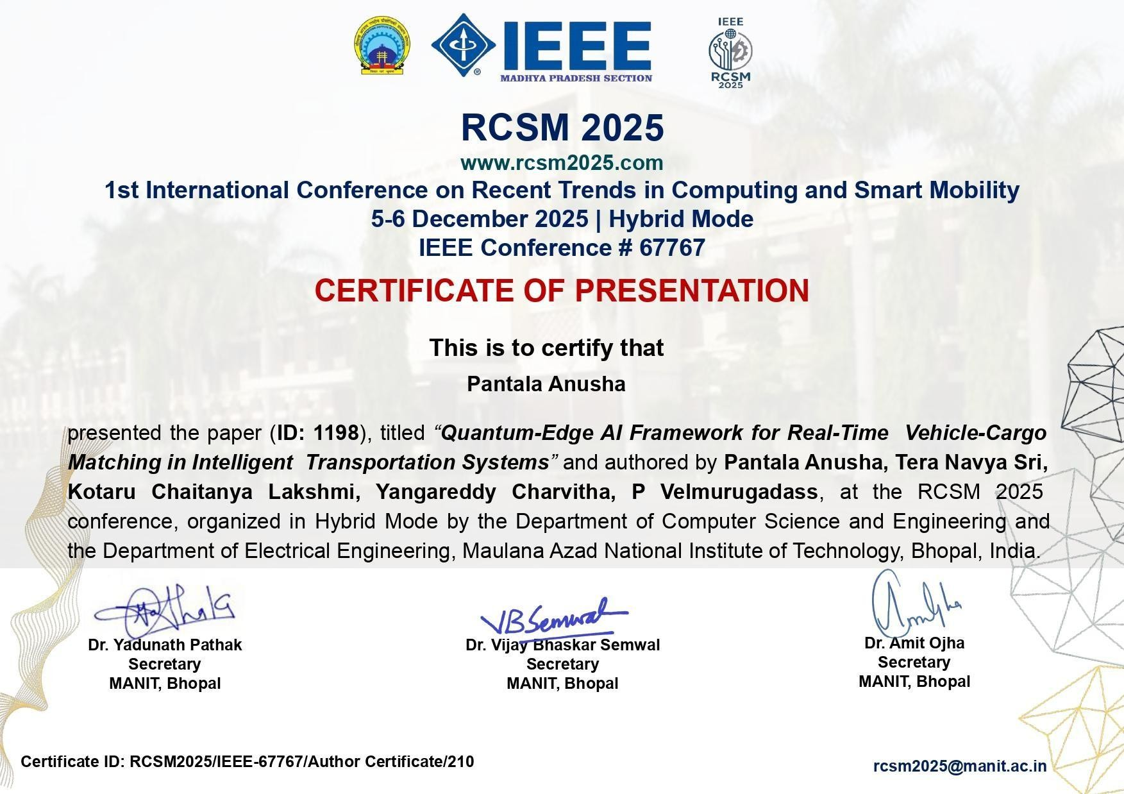


Page 1 of 10 - Cover Page Submission ID trn:oid:::1:3408170507

Anusha232902_Capstone Project Research Paper.pdf

Anusha
Turnitin

Document Details

Submission ID trn:oid:::1:3408170507

6 Pages

4,978 Words

32,015 Characters
Submissi on Date
Nov 12, 2025, 11:39 AM GMT-5

Downlo ad Date
Nov 12, 2025, 11:40 AM GMT-5

File Name tmpnolel3ir.pdf
File Size
375.9 KB

 Page 2 of 10 - Integrity Overview Submission ID trn:oid:::1:3408170507

7% Overall Similarity
The combined total of all matches, including overlapping sources, for each database.

Match Groups
27 Not Cited or Quoted 7%
Top Sources
7% Internet sources

Matches with neither in-text citation nor quotation marks 6% Publications


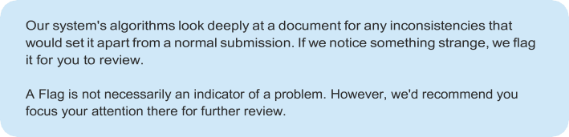
0 Missing Quotations 0%
Matches that are still very similar to source material

0 Missing Citation 0%
Matches that have quotation marks, but no in-text citation

0 Cited and Quoted 0%
Matches with in-text citation present, but no quotation marks

Integrity Flags
0 Integrity Flags for Review
No suspicious text manipulations found.
3% Submitted works (Student Papers)



INTERNAL QUALITY ASSURANCE CELL PROJECT AUDIT REPORT

This is to certify that the project work entitled “VAAHANSETU: A REAL-TIME SMART BOOKING PLATFORM CONNECTING CUSTOMERS WITH GOODS VEHICLE
SERVICES” categorized as an internal project done by Kotaru Chaitanya Lakshmi, Tera Navya Sri, Yangareddy Charvitha, Pantala Anusha of the Department of Computer Science and Engineering, under the guidance of Dr. P. Velmurugadass during the Even semester of the academic year 2025 - 2026 are as per the quality guidelines specified by IQAC.

Quality Grade

Deputy Dean (IQAC)

Administrative Quality Assurance Dean (IQAC)

